LAB - 6

Name:Rhythm Kachhwaha
SAP:500107218
Batch - 4 AIML

- Customer Churn Prediction (regression) Dataset: Telecom customer data (e.g., from Kaggle): Suggested link - https://www.kaggle.com/datasets/abhinav89/telecom-customer Data preprocessing (handling missing values, outliers, feature scaling): Suggested link - https://medium.com/womenintechnology/data-preprocessing-steps-for-machine-learning-in-phyton-part-1-18009c6f1153 Exploratory data analysis (EDA) to identify potential predictors: Samples: https://www.kaggle.com/code/julnazz/exploratory-data-analysis-eda-and-feature-select Building a simple linear regression model Evaluating model performance using accuracy, precision, recall, F1-score; Suggested link - https://medium.com/@maxgrossman10/accuracy-recall-precision-f1-score-with-python-4f2ee97e0d6

import pandas as pd
# Replace with your file path
file_path = "D:/Telecom_customer_churn.csv" df = pd.read_csv(file_path)
# Check for missing values
missing_values = df.isnull().sum()
# Drop rows with missing values (if reasonable)
df_cleaned = df.dropna()
# Alternatively, fill missing values (e.g., using mean or median)
df_filled = df.fillna(df.mean())
C:\Users\Rhythm\AppData\Local\Temp\ipykernel_504\3485450516.py:8: FutureWarning: The default value of numeric_only in DataFrame.mean is deprecated. In a future version, it will default to False. In addition, specifying 'numeric_only=None' is deprecated. Select only valid columns or specify the value of numeric_only to silence this warning.
df_filled = df.fillna(df.mean())
import numpy as np
# Using IQR to detect outliers
Q1 = df.quantile(0.25) Q3 = df.quantile(0.75)
IQR = Q3 - Q1
# Filter out outliers
df_outliers_removed = df[~((df < (Q1 - 1.5 * IQR)) | (df > (Q3 + 1.5 * IQR))).any(axis=1)]
C:\Users\Rhythm\AppData\Local\Temp\ipykernel_504\3720908586.py:3: FutureWarning: The default value of numeric_only in DataFrame.quantile is deprecated. In a future version, it will default to False. Select only valid columns or specify the value of numeric_only to silence this warning.
Q1 = df.quantile(0.25) C:\Users\Rhythm\AppData\Local\Temp\ipykernel_504\3720908586.py:4: FutureWarning: The default value of numeric_only in DataFrame.quantile is deprecated. In a future version, it will default to False. Select only valid columns or specify the value of numeric_only to silence this warning.
Q3 = df.quantile(0.75) C:\Users\Rhythm\AppData\Local\Temp\ipykernel_504\3720908586.py:7: FutureWarning: Automatic reindexing on DataFrame vs Series comparisons is deprecated and will raise ValueError in a future version. Do `left, right = left.align(right, axis=1, copy=False)` before e.g. `left == right`
df_outliers_removed = df[~((df < (Q1 - 1.5 * IQR)) | (df > (Q3 + 1.5
* IQR))).any(axis=1)]
from sklearn.preprocessing import StandardScaler, MinMaxScaler,
LabelEncoder import numpy as np
import pandas as pd
# Assuming 'df_outliers_removed' is the DataFrame after handling outliers
# Step 1: Select only numeric columns
numeric_cols = df_outliers_removed.select_dtypes(include=[np.number]).columns df_numeric = df_outliers_removed[numeric_cols]
# Step 2: Apply Standardization to numeric columns
scaler = StandardScaler()
df_standardized = pd.DataFrame(scaler.fit_transform(df_numeric), columns=df_numeric.columns)
# Step 3: Apply Normalization (Optional) to numeric columns
normalizer = MinMaxScaler()
df_normalized = pd.DataFrame(normalizer.fit_transform(df_numeric), columns=df_numeric.columns)
# Step 4: Keep non-numeric columns (categorical features)
df_non_numeric = df_outliers_removed.drop(columns=numeric_cols)
# Step 5: Apply Label Encoding to categorical features
label_encoder = LabelEncoder()
# Apply label encoding to each categorical column
for col in df_non_numeric.select_dtypes(include=['object']).columns: df_non_numeric[col] =
label_encoder.fit_transform(df_non_numeric[col])
# Step 6: Recombine the processed numeric columns (choose standardized or normalized) with the encoded categorical columns
# If you want to use standardized numeric data: df_final_standardized = pd.concat([df_standardized, df_non_numeric], axis=1)
# If you want to use normalized numeric data: df_final_normalized = pd.concat([df_normalized, df_non_numeric], axis=1)
import pandas as pd import numpy as np import seaborn as sns
import matplotlib.pyplot as plt
from sklearn.ensemble import RandomForestClassifier from sklearn.model_selection import train_test_split
# Step 1: Load the dataset
# Use the full file path, for example:
df = pd.read_csv("D:/Telecom_customer_churn.csv")
# Step 2: Basic Information about the dataset print("Data Overview:\n", df.info()) print("\nMissing Values:\n", df.isnull().sum()) print("\nBasic Statistics:\n", df.describe())
# Step 3: Univariate Analysis - Distribution of target variable 'churn'
sns.countplot(x='churn', data=df) plt.title('Churn Distribution') plt.show()
# Step 4: Univariate Analysis - Check the distribution of numerical features
df.hist(bins=20, figsize=(20,15)) plt.show()
# Step 5: Bivariate Analysis - Check correlation of features with 'churn'
corr_matrix = df.corr()
churn_corr = corr_matrix['churn'].sort_values(ascending=False) print("Features Correlated with Churn:\n", churn_corr)
# Step 6: Bivariate Analysis - Visualizing potential relationships with 'churn'
plt.figure(figsize=(12,6)) sns.boxplot(x='churn', y='totrev', data=df) plt.title('Total Revenue vs Churn') plt.show()
plt.figure(figsize=(12,6)) sns.boxplot(x='churn', y='mou_Mean', data=df) plt.title('Mean Minutes of Usage vs Churn') plt.show()
# Step 7: Multivariate Analysis - Correlation heatmap of the top 10 features
plt.figure(figsize=(10, 8))
sns.heatmap(df.corr(), annot=True, cmap='coolwarm', vmin=-1, vmax=1) plt.title('Correlation Heatmap')
plt.show()
# Step 8: Outlier Detection
# Using boxplots to detect outliers in continuous features
df_numeric = df.select_dtypes(include=[np.number])
for col in df_numeric.columns: plt.figure(figsize=(10, 5)) sns.boxplot(data=df, y=col) plt.title(f'Outliers in {col}') plt.show()
# Step 9: Feature Selection (Feature Importance)
# Prepare the data for training (assuming label-encoded or binary columns)
X = df.drop(columns=['churn', 'Customer_ID']) # Dropping 'churn' (target) and ID column
y = df['churn']
# One-hot encoding for categorical features if needed
X = pd.get_dummies(X, drop_first=True)
# Check for missing values
print("Missing values in X:\n", X.isnull().sum()) print("Missing values in y:\n", y.isnull().sum())
# Split data into training and test sets
X_train, X_test, y_train, y_test = train_test_split(X, y, test_size=0.3, random_state=42)
# Check shapes of training data print("X_train shape:", X_train.shape) print("y_train shape:", y_train.shape)
# Train a RandomForestClassifier to identify important features model = RandomForestClassifier(n_estimators=100, random_state=42) model.fit(X_train, y_train)
# Display feature importance
importances = model.feature_importances_ features = X.columns
# Plot feature importance
feature_importance_df = pd.DataFrame({'Feature': features, 'Importance': importances})
feature_importance_df = feature_importance_df.sort_values(by='Importance', ascending=False)
plt.figure(figsize=(12,6)) sns.barplot(x='Importance', y='Feature', data=feature_importance_df.head(10))
plt.title('Top 10 Important Features for Churn Prediction') plt.show()

<class 'pandas.core.frame.DataFrame'> RangeIndex: 100000 entries, 0 to 99999 Data columns (total 100 columns):  # Column Non-Null Count |  |  | Dtype
0 | rev_Mean | 99643 non-null | float64
1 | mou_Mean | 99643 non-null | float64
2 | totmrc_Mean | 99643 non-null | float64
3 | da_Mean | 99643 non-null | float64
4 | ovrmou_Mean | 99643 non-null | float64
5 | ovrrev_Mean | 99643 non-null | float64
6 | vceovr_Mean | 99643 non-null | float64
7 | datovr_Mean | 99643 non-null | float64
8 | roam_Mean | 99643 non-null | float64
9 | change_mou | 99109 non-null | float64
10 | change_rev | 99109 non-null | float64
11 | drop_vce_Mean | 100000 non-null | float64
12 | drop_dat_Mean | 100000 non-null | float64
13 | blck_vce_Mean | 100000 non-null | float64
14 | blck_dat_Mean | 100000 non-null | float64
15 | unan_vce_Mean | 100000 non-null | float64
16 | unan_dat_Mean | 100000 non-null | float64
17 | plcd_vce_Mean | 100000 non-null | float64
18 | plcd_dat_Mean | 100000 non-null | float64
19 | recv_vce_Mean | 100000 non-null | float64
20 | recv_sms_Mean | 100000 non-null | float64
21 | comp_vce_Mean | 100000 non-null | float64
22 | comp_dat_Mean | 100000 non-null | float64
23 | custcare_Mean | 100000 non-null | float64
24 | ccrndmou_Mean | 100000 non-null | float64
25 | cc_mou_Mean | 100000 non-null | float64
26 | inonemin_Mean | 100000 non-null | float64
27 | threeway_Mean | 100000 non-null | float64
28 | mou_cvce_Mean | 100000 non-null | float64
29 | mou_cdat_Mean | 100000 non-null | float64
30 | mou_rvce_Mean | 100000 non-null | float64
31 | owylis_vce_Mean | 100000 non-null | float64
32 | mouowylisv_Mean | 100000 non-null | float64
33 | iwylis_vce_Mean | 100000 non-null | float64
34 | mouiwylisv_Mean | 100000 non-null | float64
35 | peak_vce_Mean | 100000 non-null | float64
36 | peak_dat_Mean | 100000 non-null | float64
37 | mou_peav_Mean | 100000 non-null | float64
38 | mou_pead_Mean | 100000 non-null | float64
39 | opk_vce_Mean | 100000 non-null | float64
40 | opk_dat_Mean | 100000 non-null | float64
41 | mou_opkv_Mean | 100000 non-null | float64

- mou_opkd_Mean 100000 non-null float64
- drop_blk_Mean 100000 non-null float64
- attempt_Mean 100000 non-null float64
- complete_Mean 100000 non-null float64
- callfwdv_Mean 100000 non-null float64
- callwait_Mean 100000 non-null float64
- churn 100000 non-null int64
- months 100000 non-null int64
- uniqsubs 100000 non-null int64
- actvsubs 100000 non-null int64
- new_cell 100000 non-null object
- crclscod 100000 non-null object
- asl_flag 100000 non-null object
- totcalls 100000 non-null int64
- totmou 100000 non-null float64
- totrev 100000 non-null float64
- adjrev 100000 non-null float64
- adjmou 100000 non-null float64
- adjqty 100000 non-null int64
- avgrev 100000 non-null float64
- avgmou 100000 non-null float64
- avgqty 100000 non-null float64
- avg3mou 100000 non-null int64
- avg3qty 100000 non-null int64
- avg3rev 100000 non-null int64
- avg6mou 97161 non-null float64
- avg6qty 97161 non-null float64
- avg6rev 97161 non-null float64
- prizm_social_one 92612 non-null object
- area 99960 non-null object
- dualband 99999 non-null object
- refurb_new 99999 non-null object
- hnd_price 99153 non-null float64
- phones 99999 non-null float64
- models 99999 non-null float64
- hnd_webcap 89811 non-null object
- truck 98268 non-null float64
- rv 98268 non-null float64
- ownrent 66294 non-null object
- lor 69810 non-null float64
- dwlltype 68091 non-null object
- marital 98268 non-null object
- adults 76981 non-null float64
- infobase 77921 non-null object
- income 74564 non-null float64
- numbcars 50634 non-null float64
- HHstatin 62077 non-null object
- dwllsize 61692 non-null object
- forgntvl 98268 non-null float64
- ethnic 98268 non-null object
mou_Mean totmrc_Mean da_Mean ovrmou_Mean
357
357
357
357
kid0_2
kid3_5
kid6_10
kid11_15
kid16_17
creditcd
98268 non-nullobject
98268 non-nullobject
98268 non-nullobject
98268 non-nullobject
98268 non-nullobject
98268 non-nullobject

98 eqpdays 99999 non-null float64
99 Customer_ID 100000 non-null int64 dtypes: float64(69), int64(10), object(21) memory usage: 76.3+ MB
Data Overview:
None
Missing Values:
rev_Mean 357

...
kid11_15 | 1732
kid16_17 | 1732
creditcd | 1732
eqpdays | 1
Customer_ID | 0

Length: 100, dtype: int64 Basic Statistics:
rev_Mean mou_Mean totmrc_Mean da_Mean ovrmou_Mean \
count 99643.000000 99643.000000 99643.000000 99643.000000
99643.000000
mean 58.719985 513.559937 46.179136 0.888828
41.072247
std 46.291677 525.168140 23.623489 2.177619
97.296150
min -6.167500 0.000000 -26.915000 0.000000
0.000000
25% 33.260000 150.750000 30.000000 0.000000
0.000000
50% 48.195000 355.500000 44.990000 0.247500
2.750000
75% 70.750000 703.000000 59.990000 0.990000
42.000000
max 3843.262500 12206.750000 409.990000 159.390000
4320.750000
ovrrev_Mean vceovr_Mean datovr_Mean roam_Mean change_mou \
count 99643.000000 99643.000000 99643.000000 99643.000000
99109.000000
mean 13.559560 13.295062 0.261318 1.286405 -
13.933818
std 30.500885 30.056089 3.126531 14.711374
276.087509
min 0.000000 0.000000 0.000000 0.000000 -
3875.000000
25% 0.000000 0.000000 0.000000 0.000000 -
87.000000
50% 1.000000 0.682500 0.000000 0.000000 -
6.250000
75% 14.437500 14.025000 0.000000 0.235000
63.000000
max 1102.400000 896.087500 423.540000 3685.200000
31219.250000

... | models | truck | rv | lor | \
count ... | 99999.000000 | 98268.000000 | 98268.000000 | 69810.000000
mean ... | 1.545825 | 0.188820 | 0.082580 | 6.177238
std ... | 0.898395 | 0.391368 | 0.275248 | 4.735267
min ... | 1.000000 | 0.000000 | 0.000000 | 0.000000
25% ... | 1.000000 | 0.000000 | 0.000000 | 2.000000
50% ... | 1.000000 | 0.000000 | 0.000000 | 5.000000
75% ... | 2.000000 | 0.000000 | 0.000000 | 9.000000
max ... | 16.000000 | 1.000000 | 1.000000 | 15.000000

adults income numbcars forgntvl eqpdays \
count 76981.000000 74564.000000 50634.000000 98268.000000
99999.000000
mean 2.530326 5.783112 1.567563 0.057974
391.932309
std 1.452819 2.182132 0.625456 0.233696
256.482193
min 1.000000 1.000000 1.000000 0.000000 -
5.000000
25% 1.000000 4.000000 1.000000 0.000000
212.000000
50% 2.000000 6.000000 1.000000 0.000000
342.000000
75% 3.000000 7.000000 2.000000 0.000000
530.000000
max 6.000000 9.000000 3.000000 1.000000
1823.000000
Customer_ID count 1.000000e+05 mean 1.050000e+06 std 2.886766e+04
min 1.000001e+06
25% 1.025001e+06
50% 1.050000e+06
75% 1.075000e+06 max 1.100000e+06
[8 rows x 79 columns]
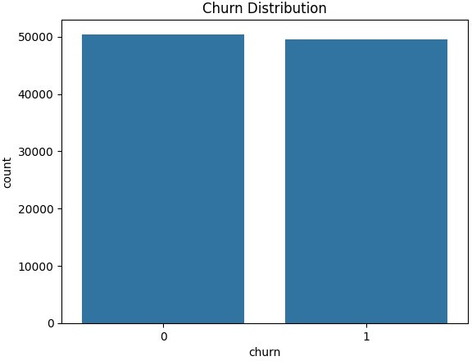
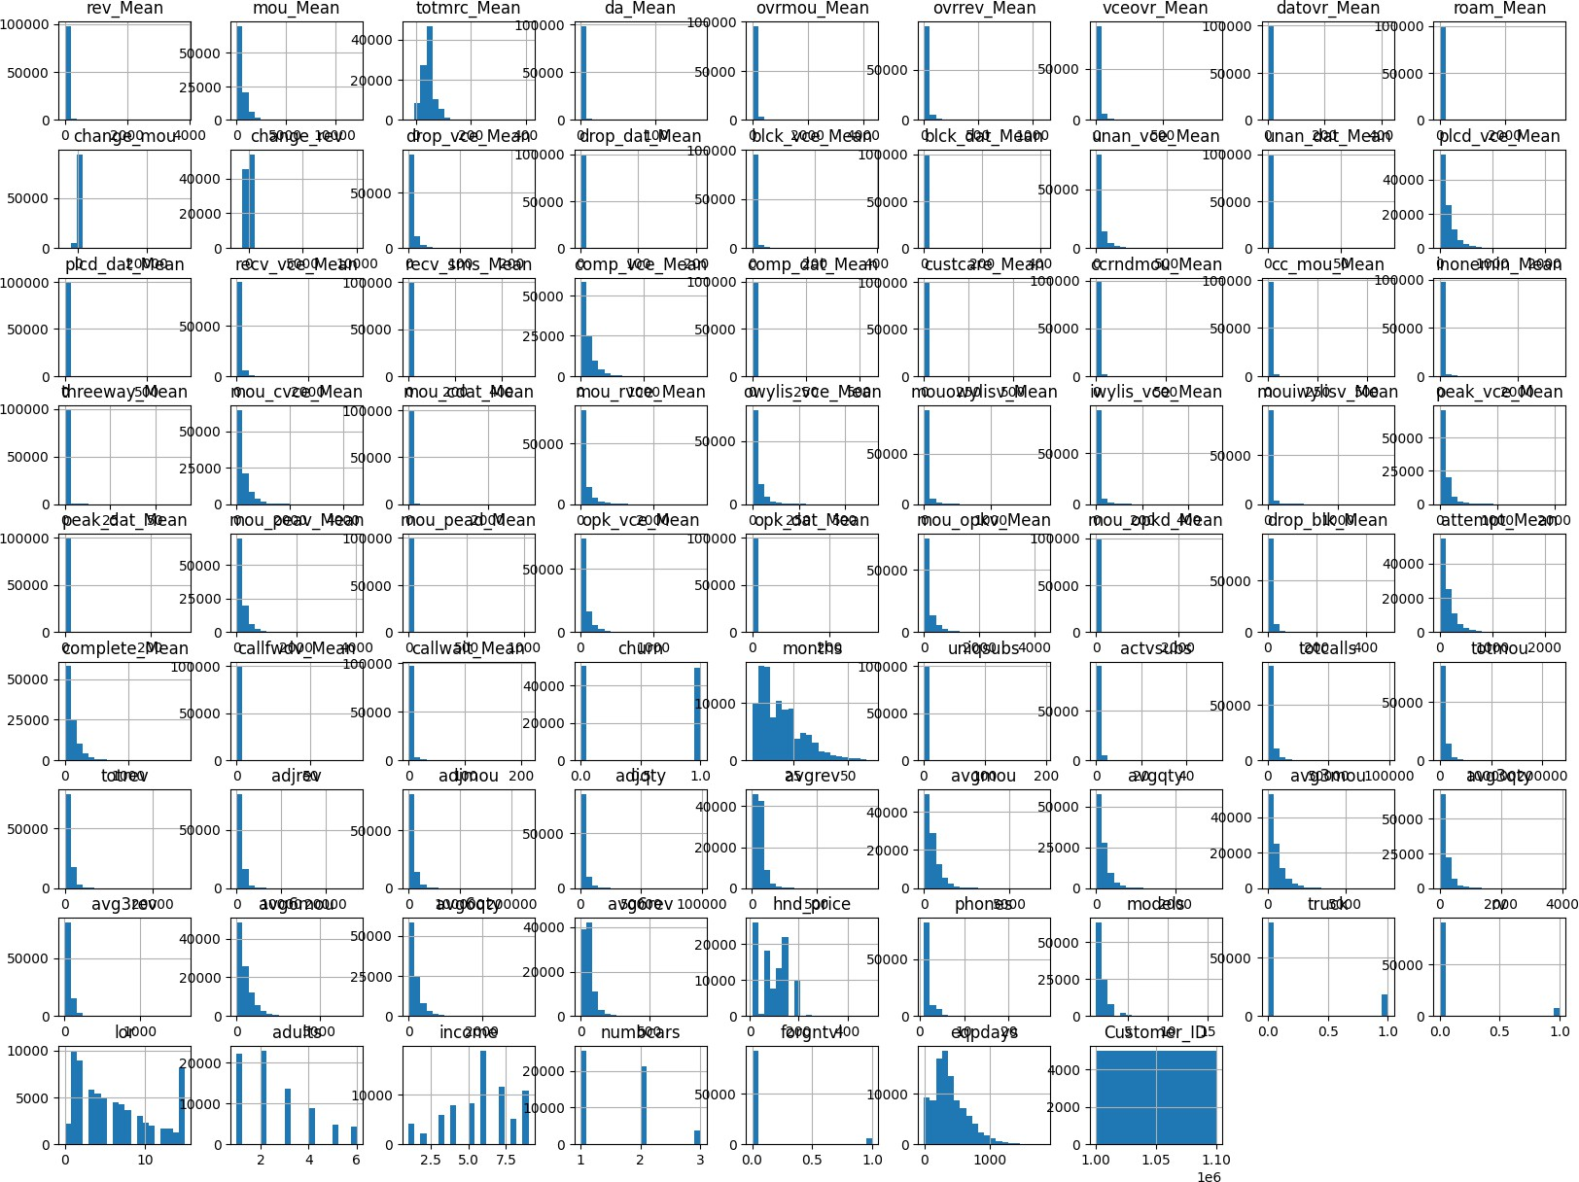
eqpdays uniqsubs vceovr_Mean ovrrev_Mean
0.112691
0.039882
0.024240
0.023736
C:\Users\Rhythm\AppData\Local\Temp\ipykernel_504\3647882210.py:27: FutureWarning: The default value of numeric_only in DataFrame.corr is deprecated. In a future version, it will default to False. Select only valid columns or specify the value of numeric_only to silence this warning.
corr_matrix = df.corr()
Features Correlated with Churn:
churn1.000000

...

Name: churn, Length: 79, dtype: float64
complete_Mean-0.051740
mou_cvce_Mean-0.052042
mou_Mean-0.057027
totmrc_Mean-0.068558
hnd_price-0.103184
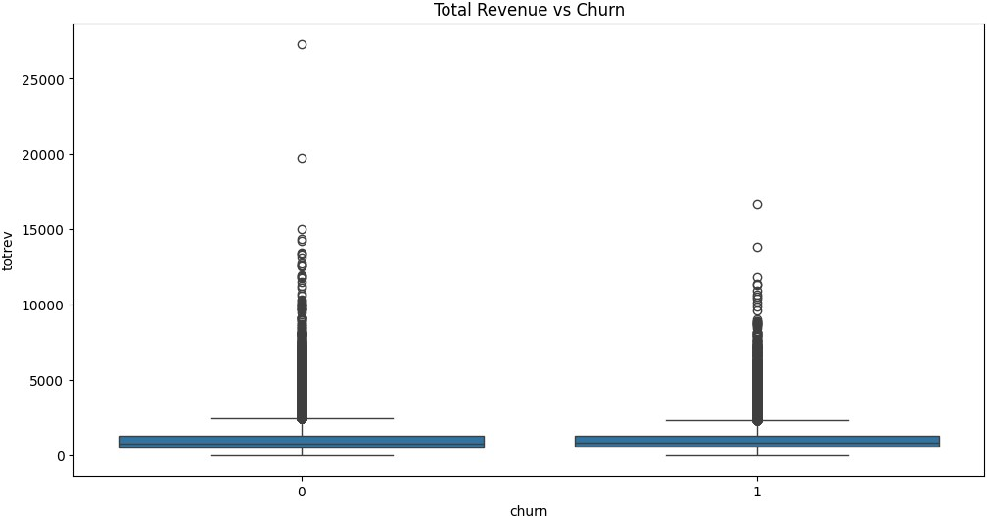
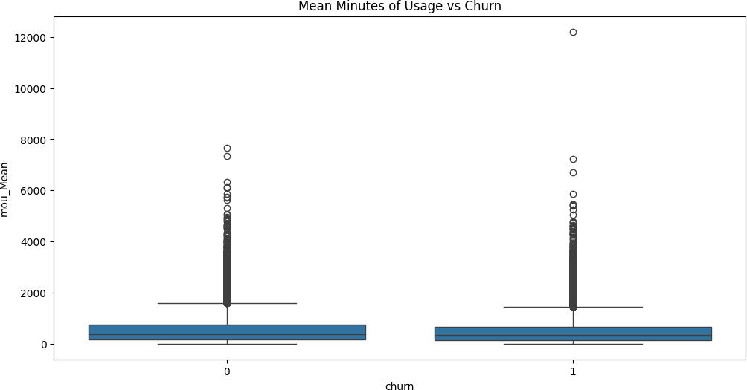
C:\Users\Rhythm\AppData\Local\Temp\ipykernel_504\3647882210.py:45: FutureWarning: The default value of numeric_only in DataFrame.corr is deprecated. In a future version, it will default to False. Select only valid columns or specify the value of numeric_only to silence this warning.
sns.heatmap(df.corr(), annot=True, cmap='coolwarm', vmin=-1, vmax=1)

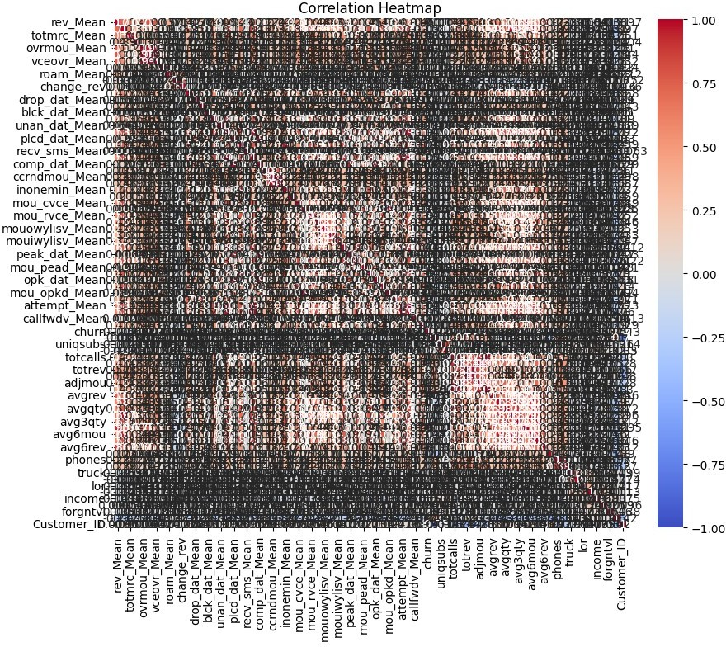
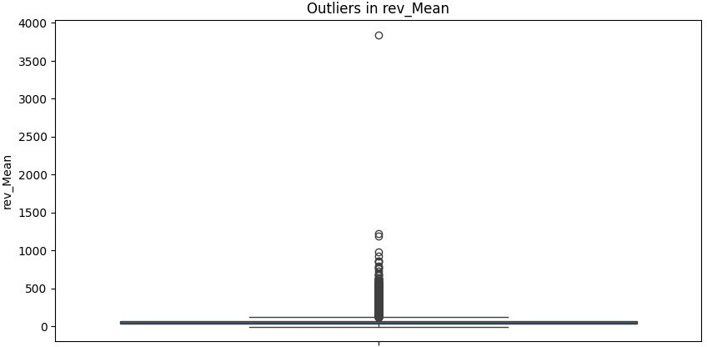
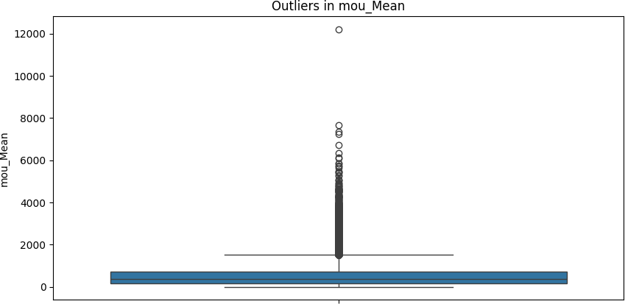
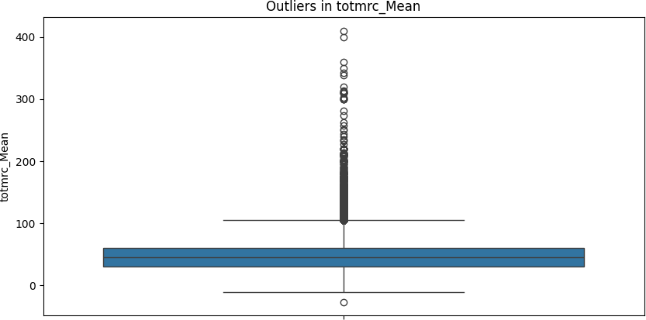
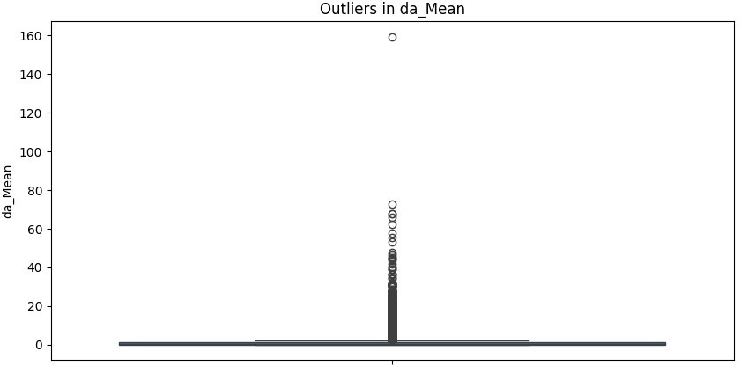
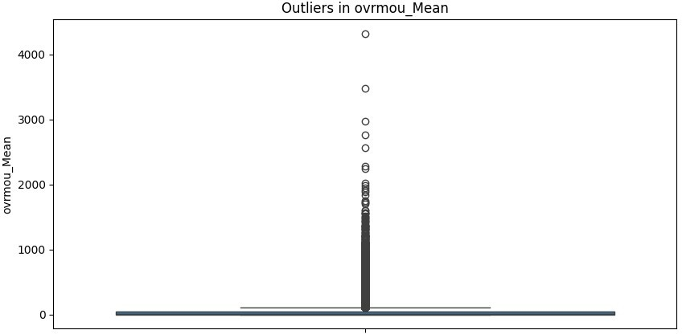
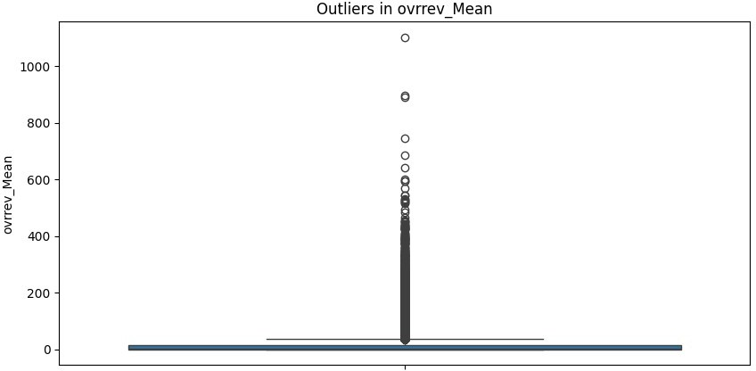
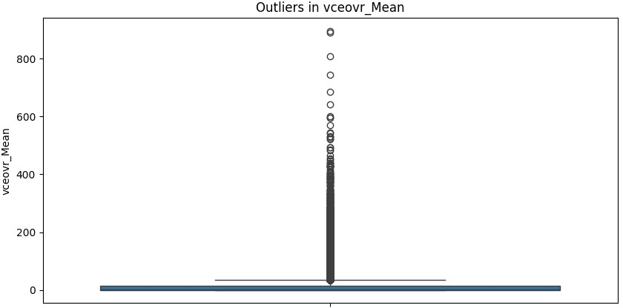
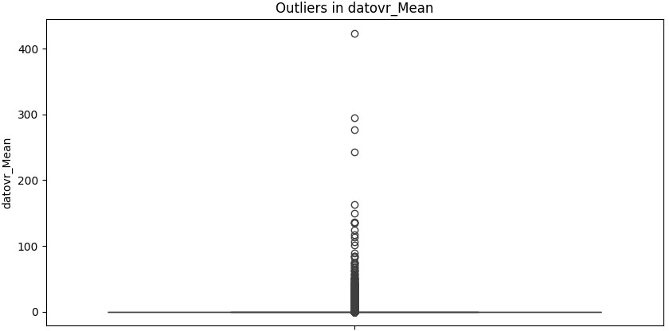
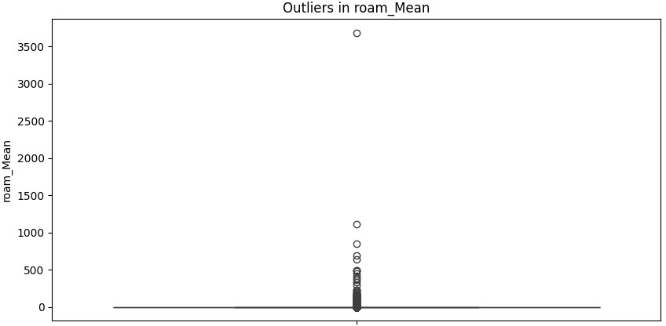
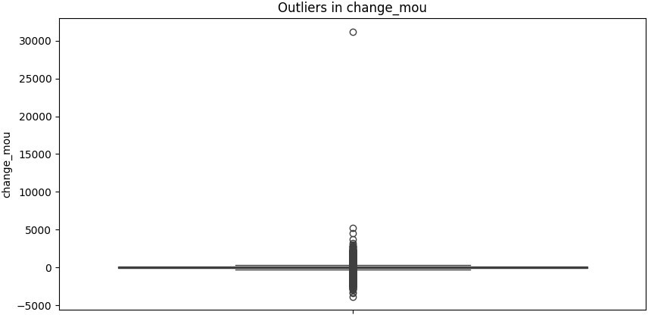
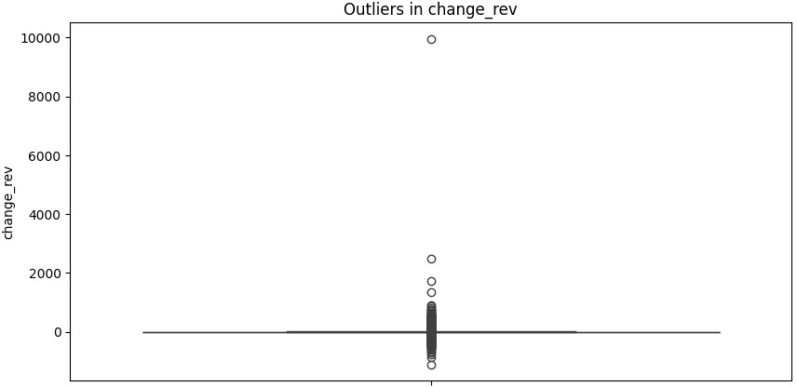
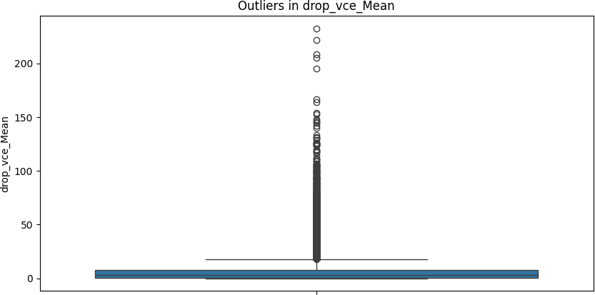
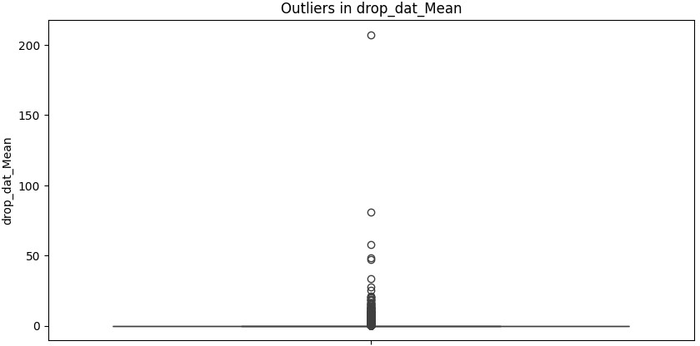
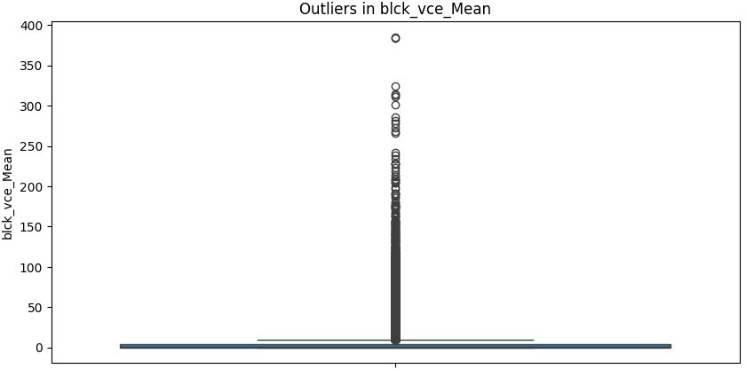
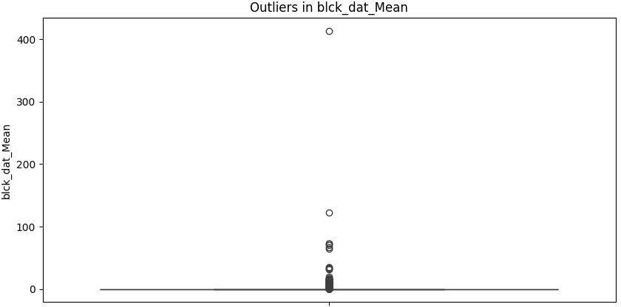
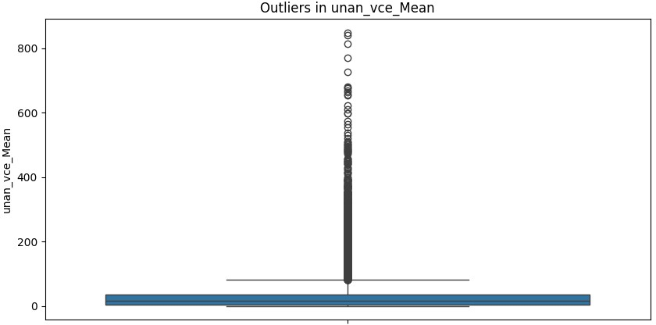
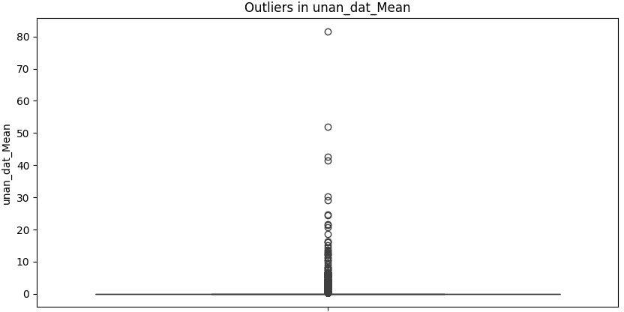
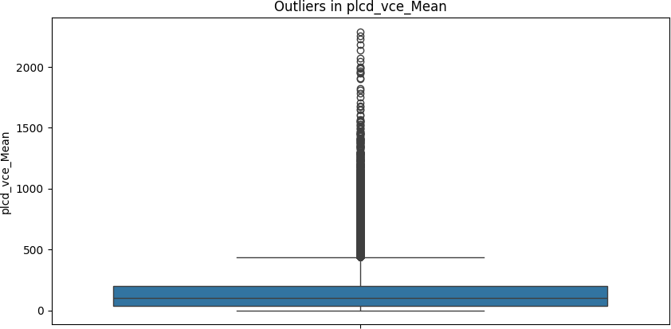
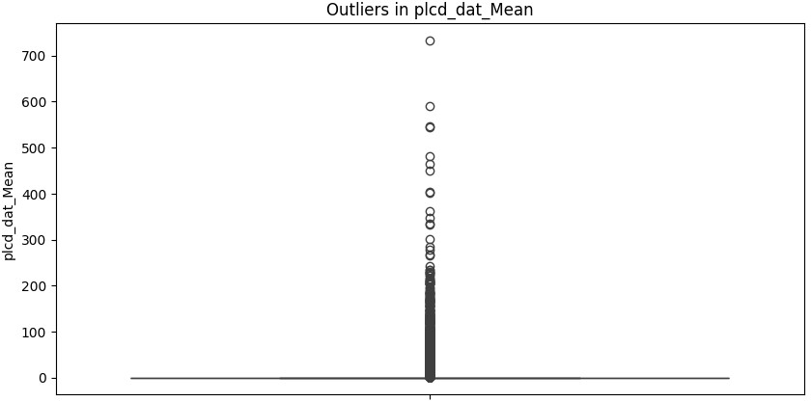
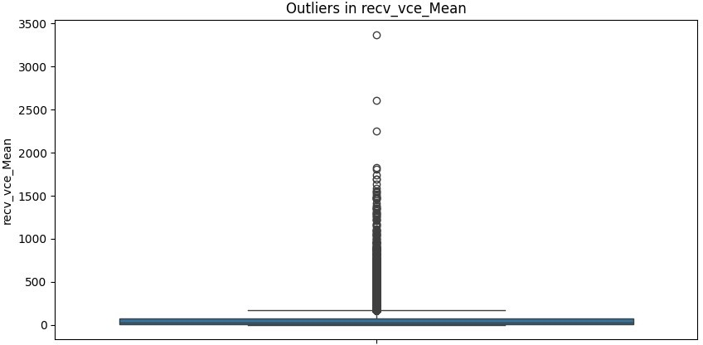
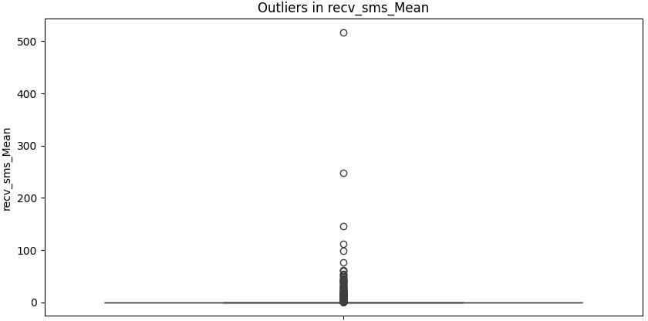
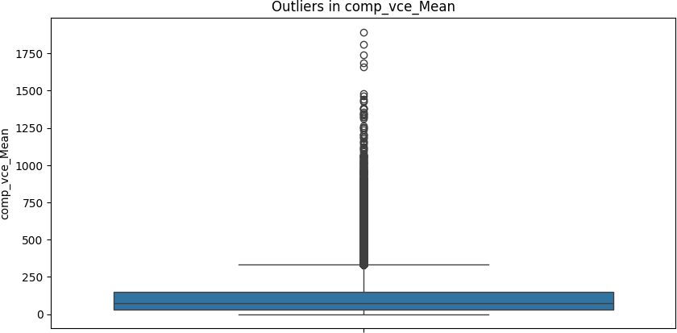
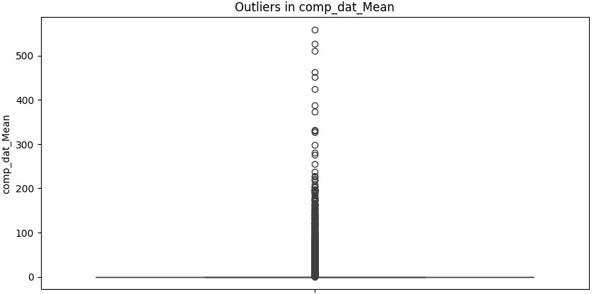
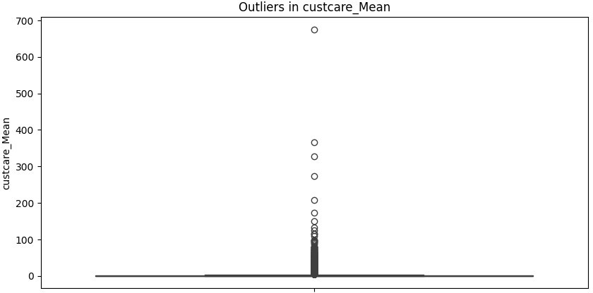
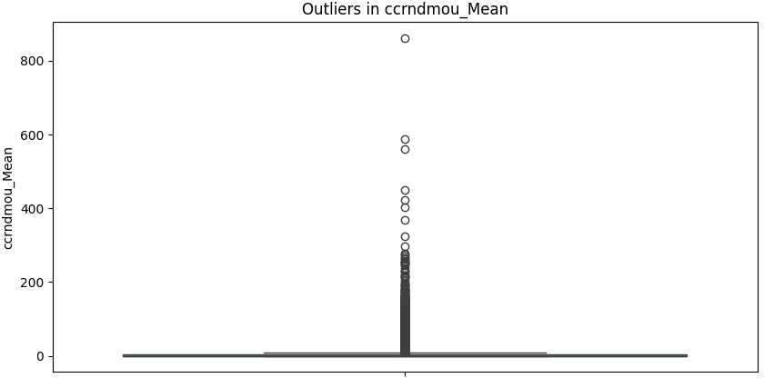
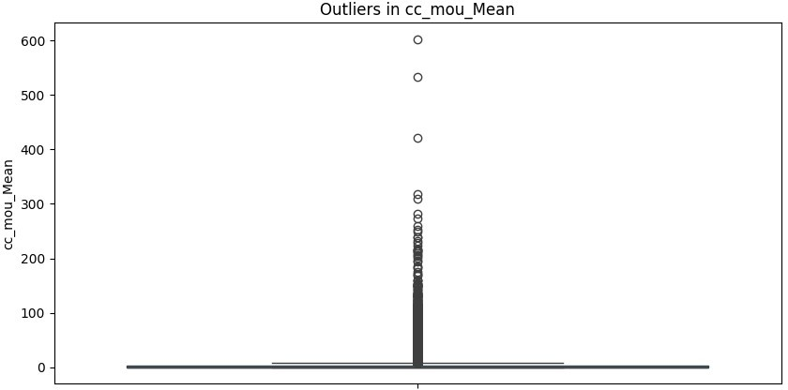
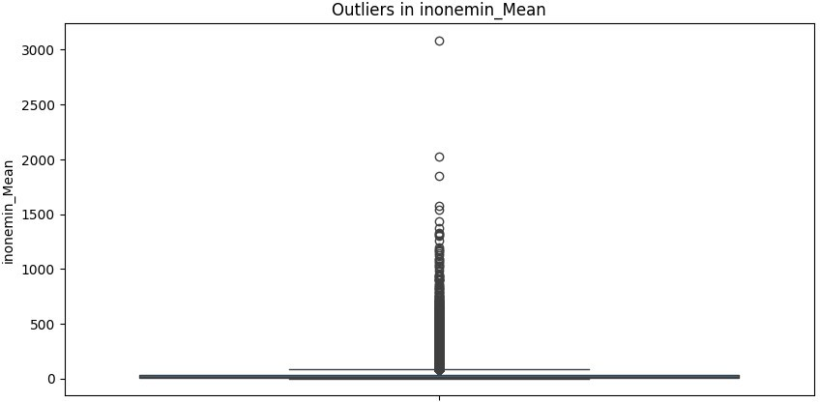
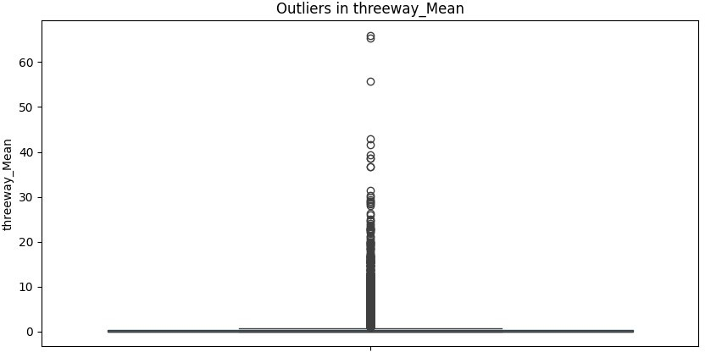
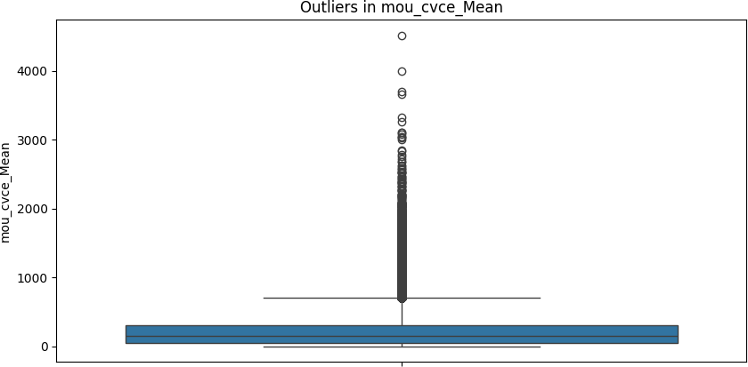
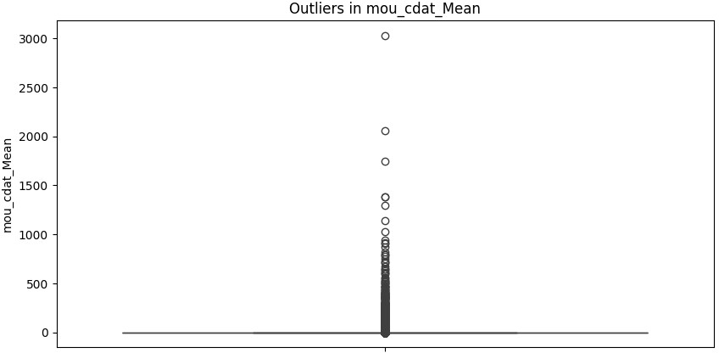
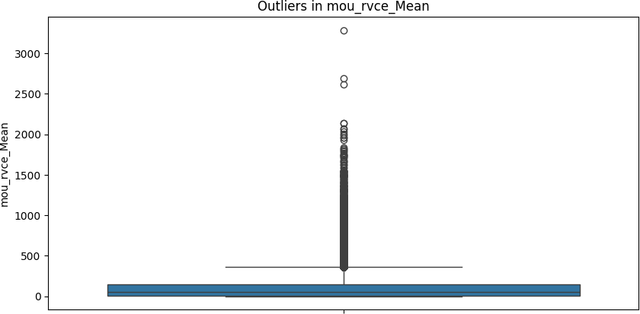
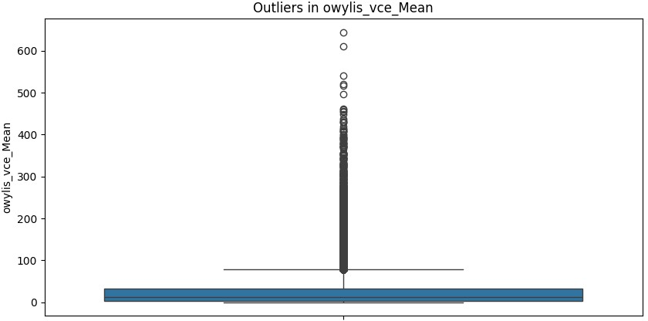
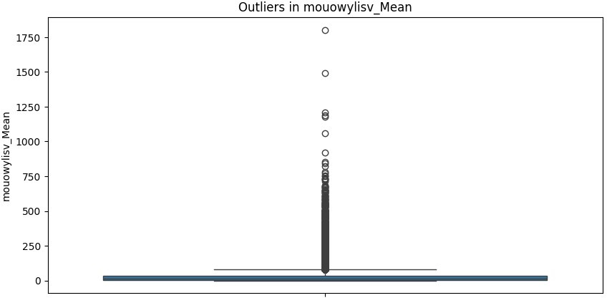
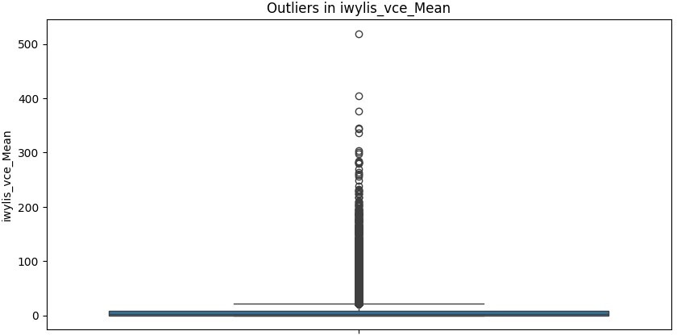
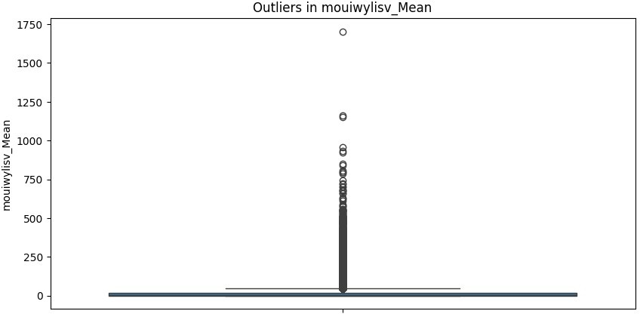
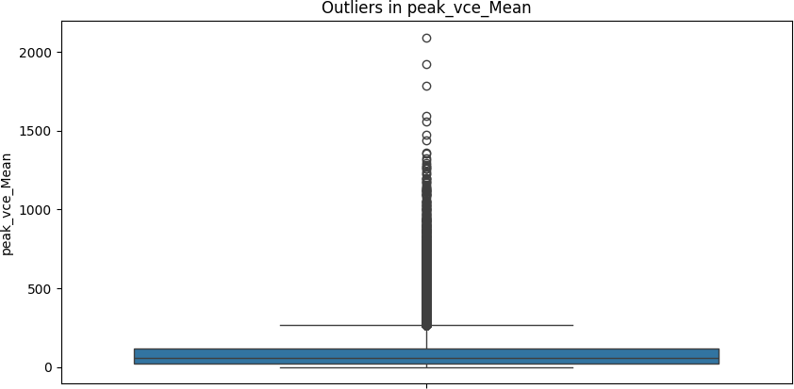
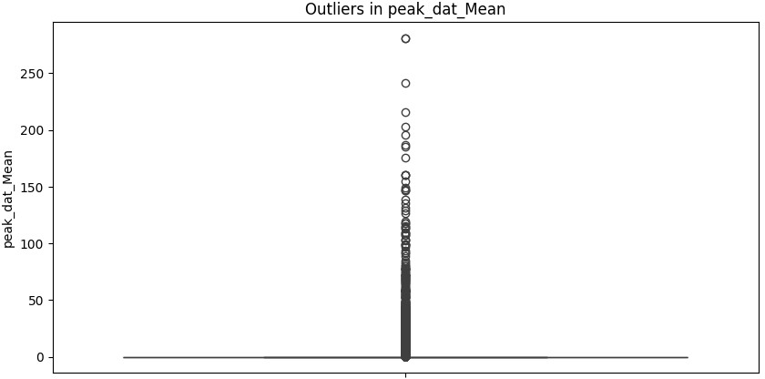
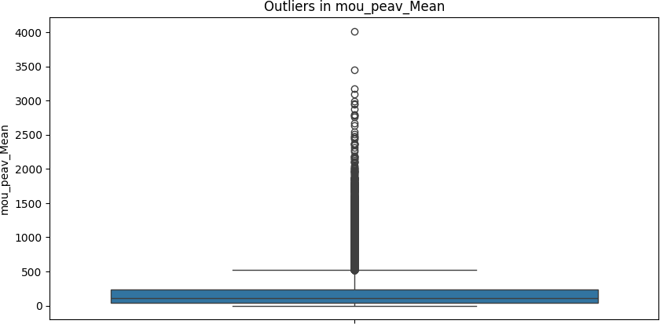
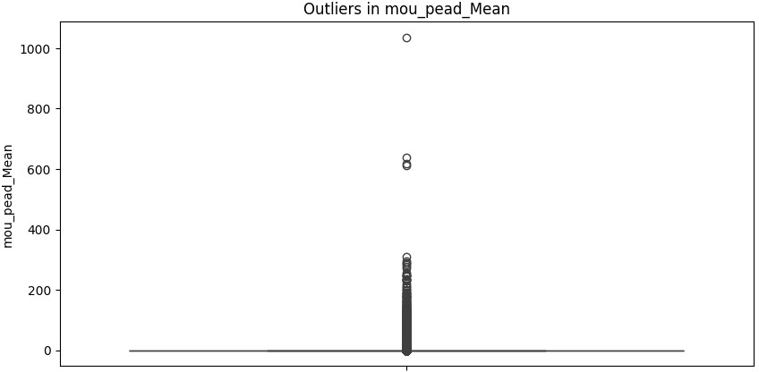
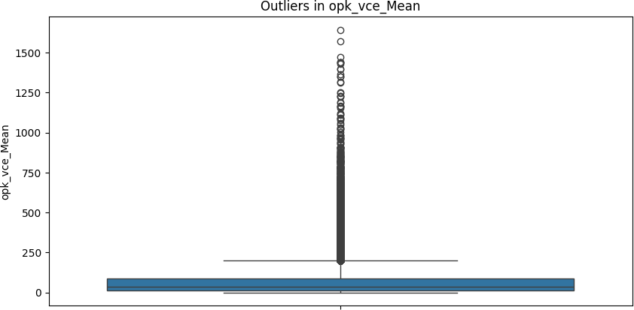
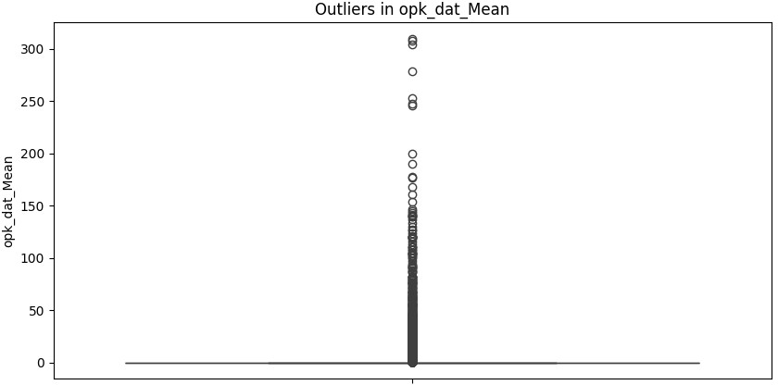
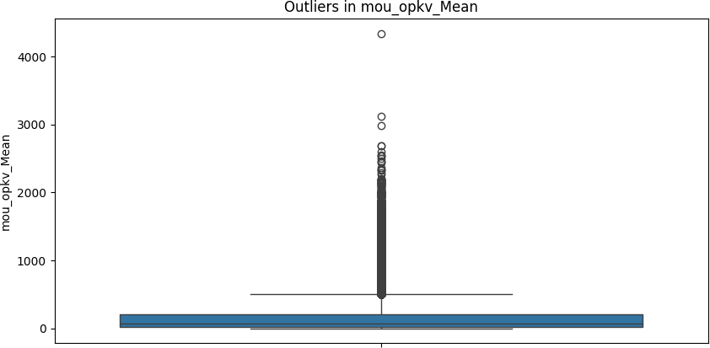
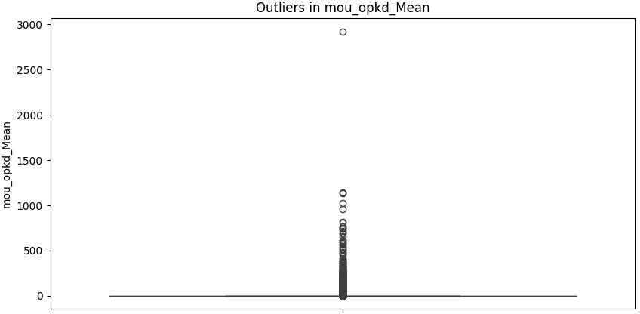
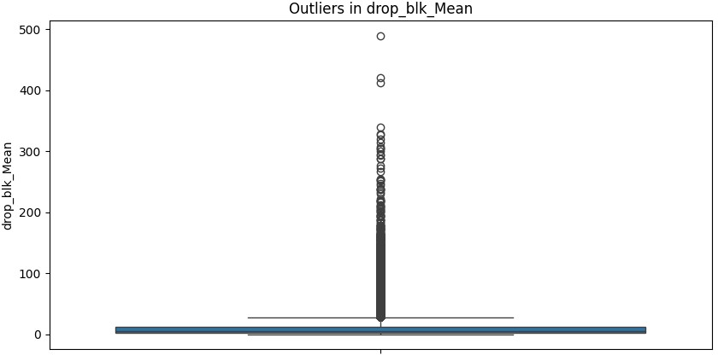
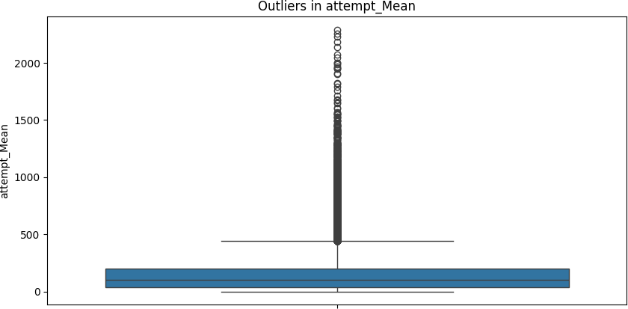
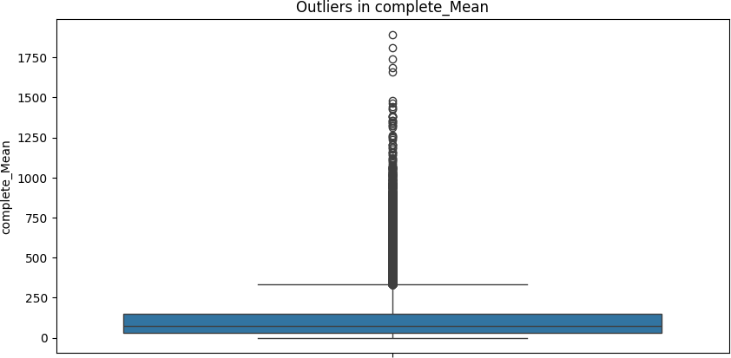
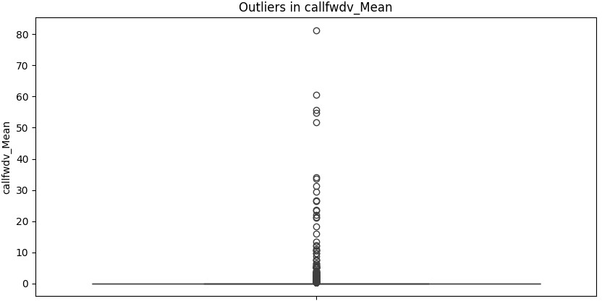
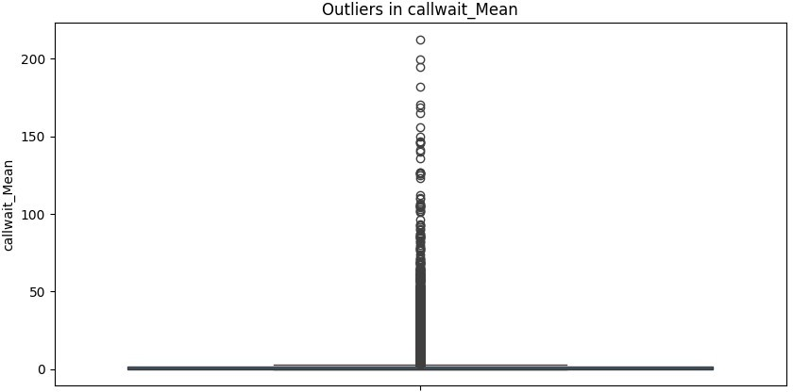
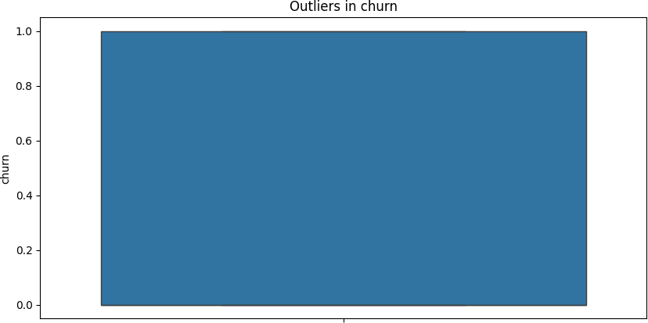
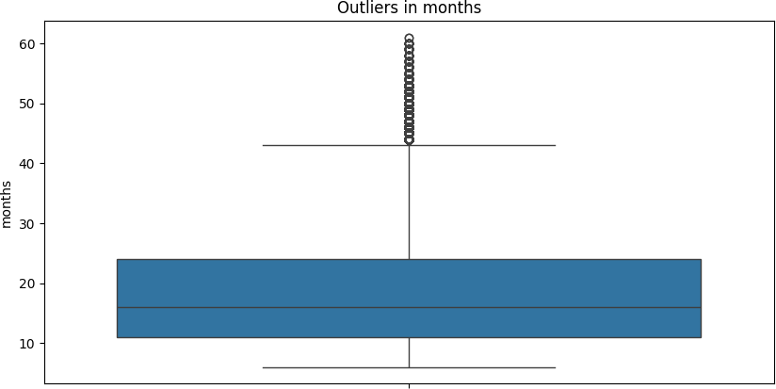
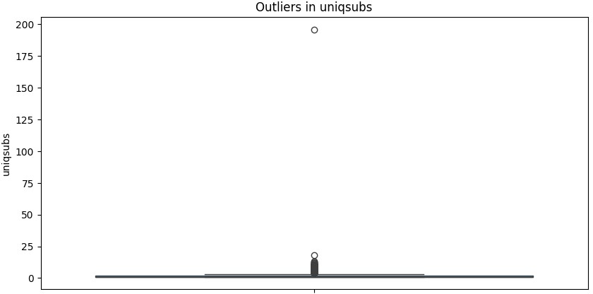
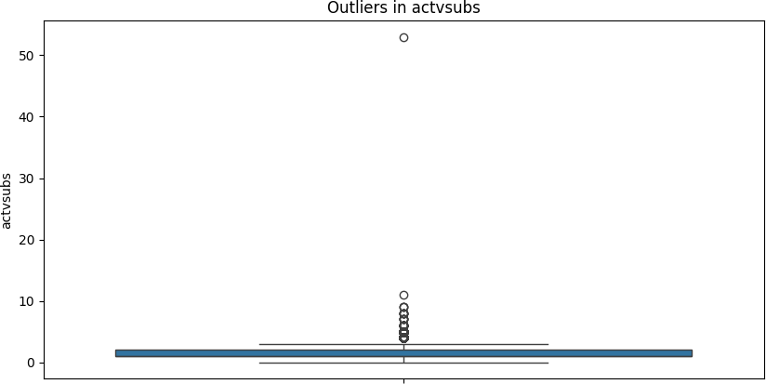
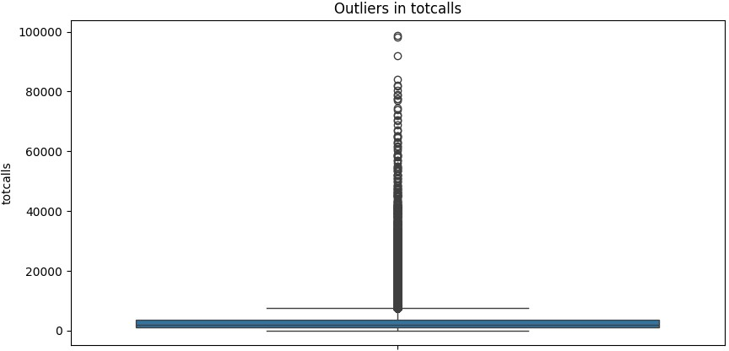
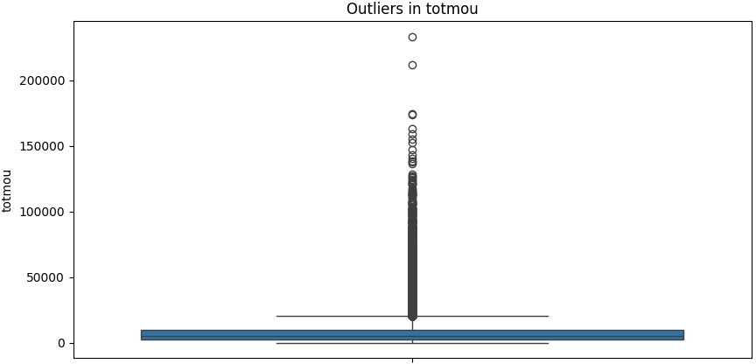
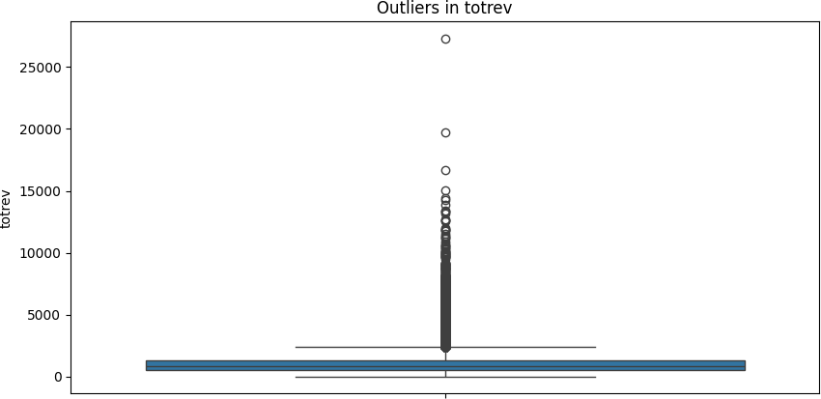
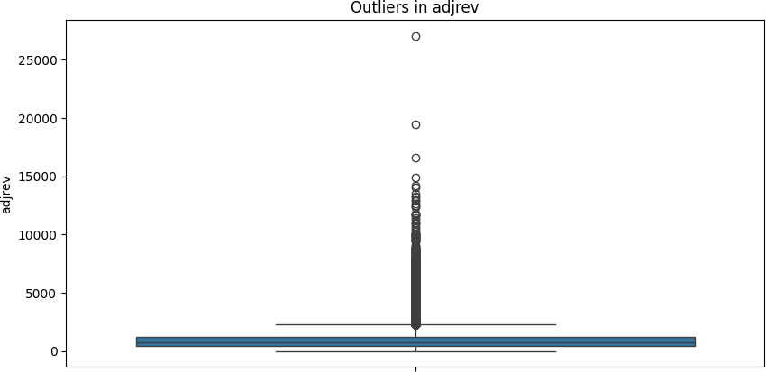
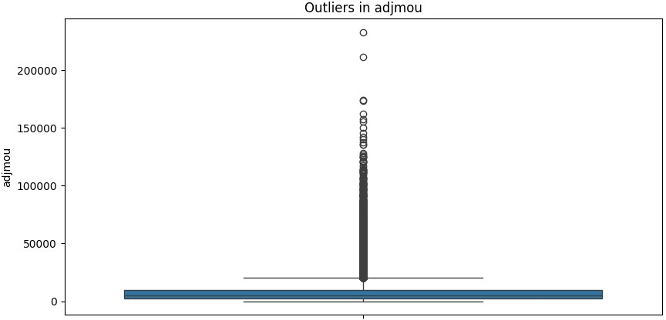
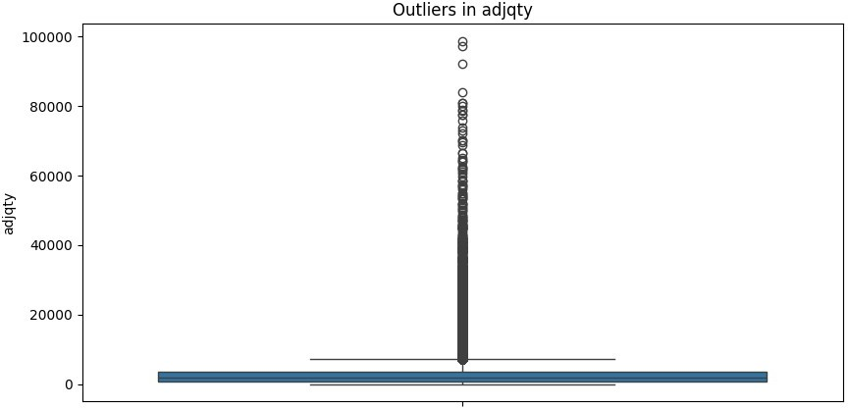
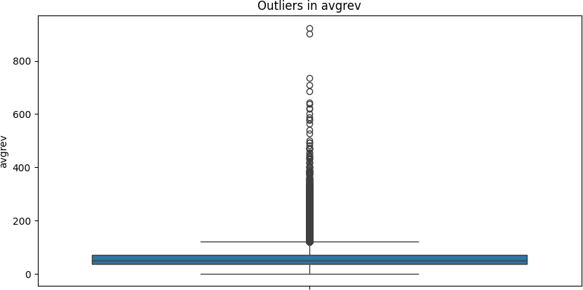
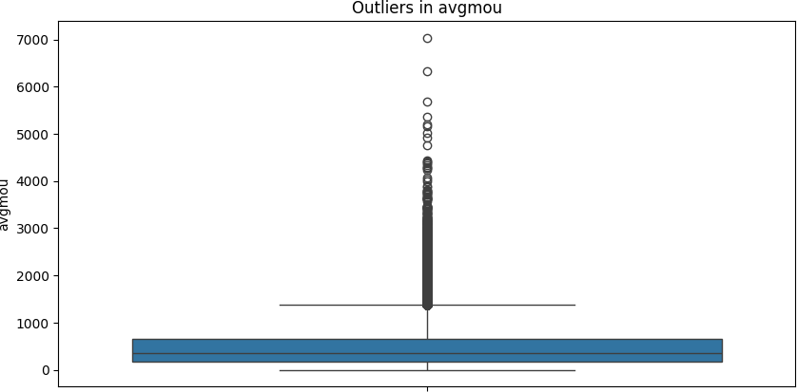
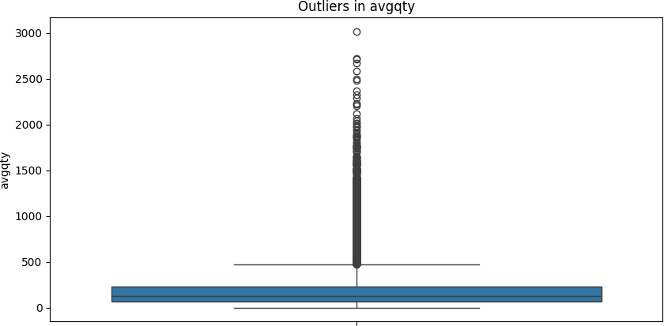
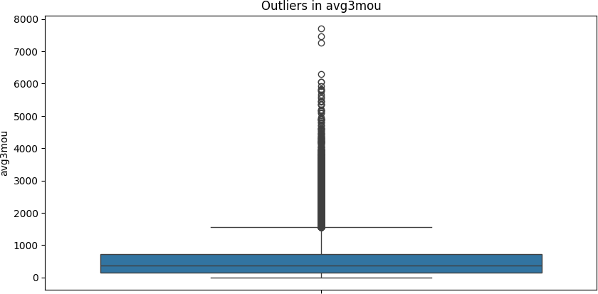
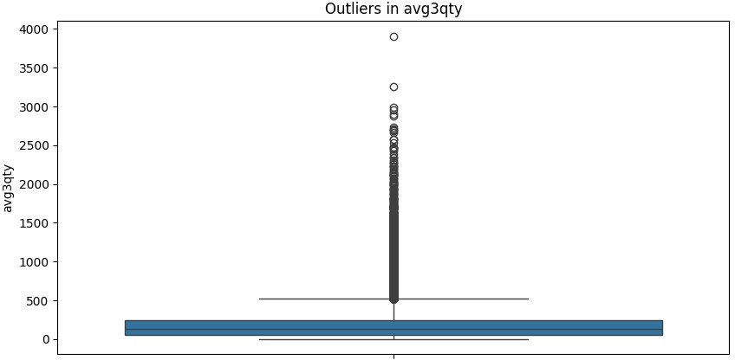
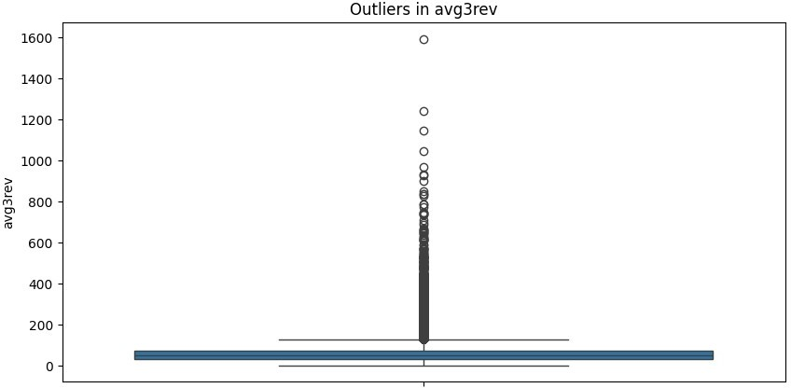
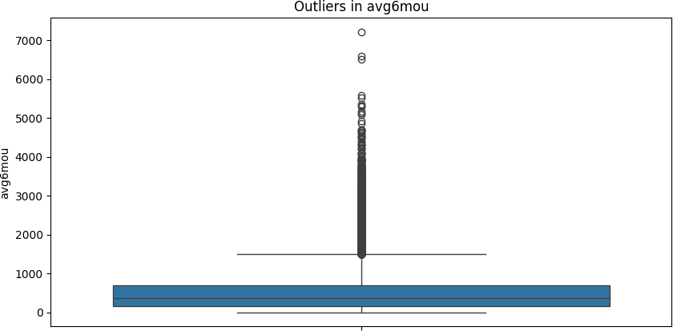
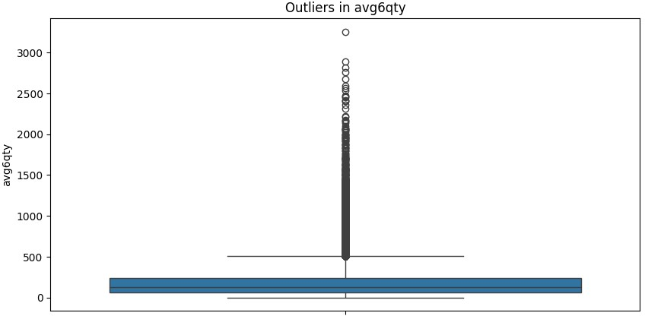
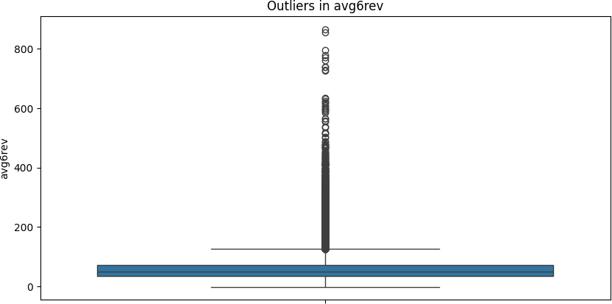
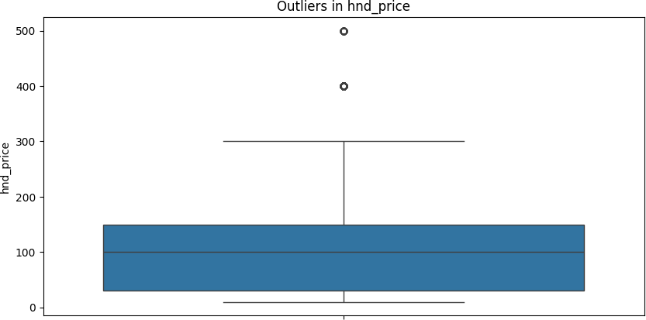
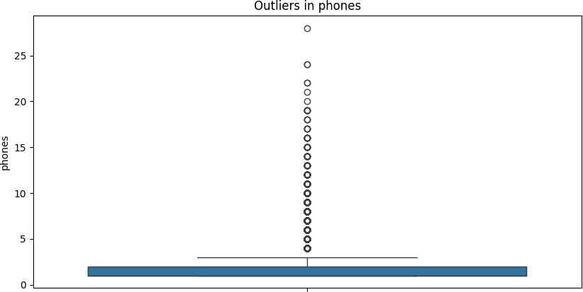
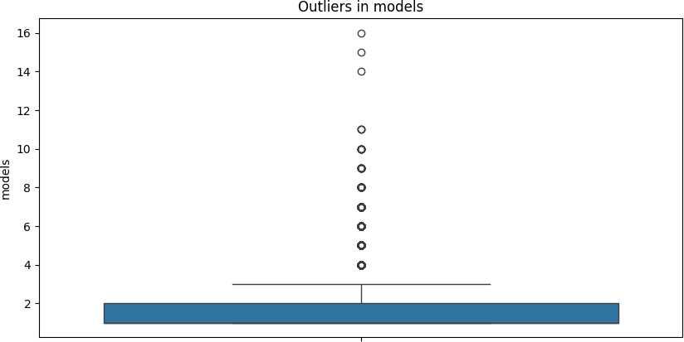
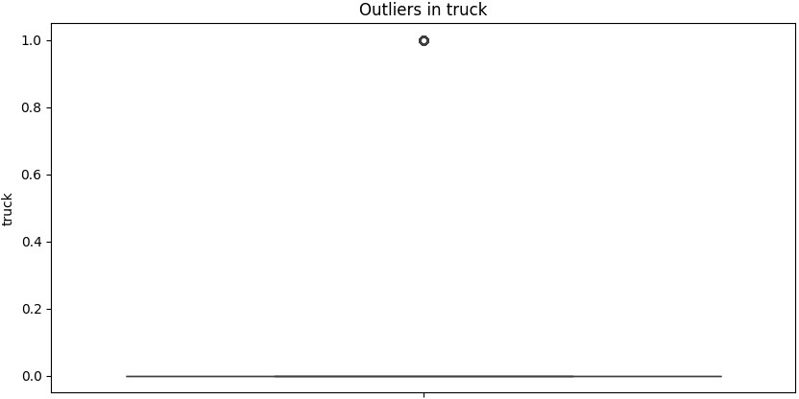
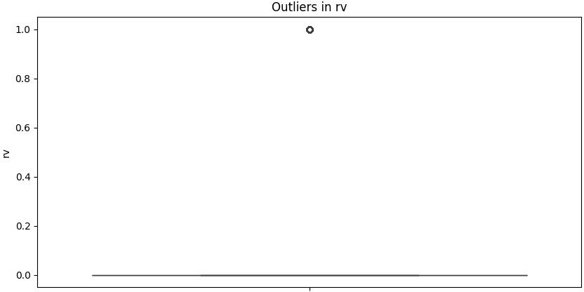
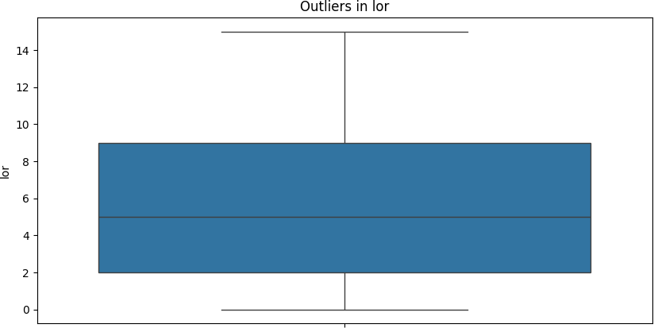
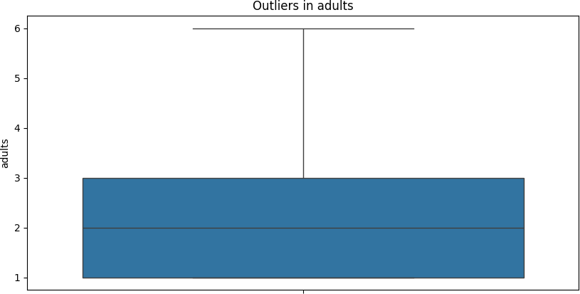
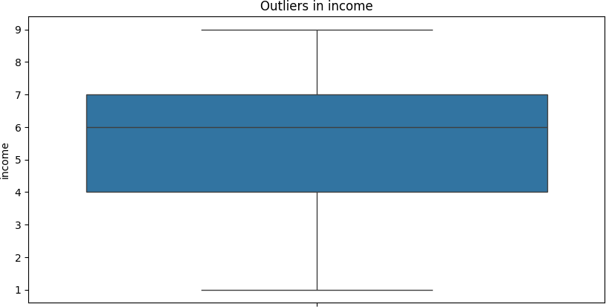
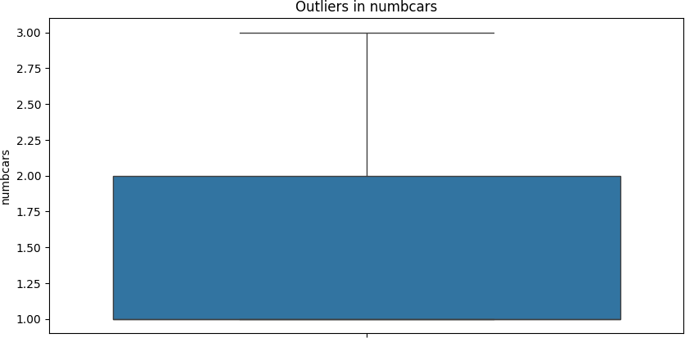
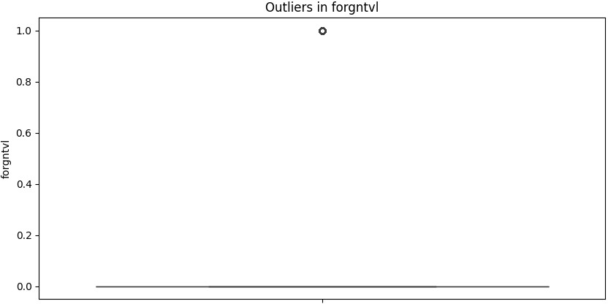
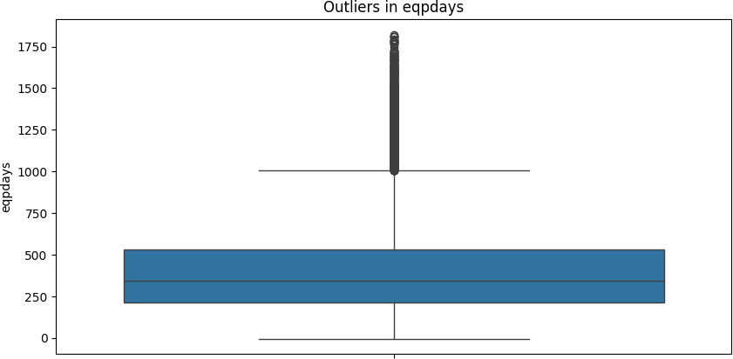
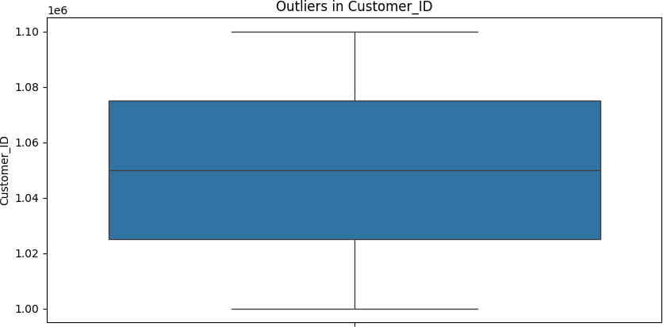
mou_Mean totmrc_Mean da_Mean ovrmou_Mean
357
357
357
357
kid3_5_Y kid6_10_Y kid11_15_Y kid16_17_Y creditcd_Y
0
0
0
0
0
Missing values in X:
rev_Mean357

...

Length: 209, dtype: int64 Missing values in y:
0
X_train shape: (70000, 209)
y_train shape: (70000,)
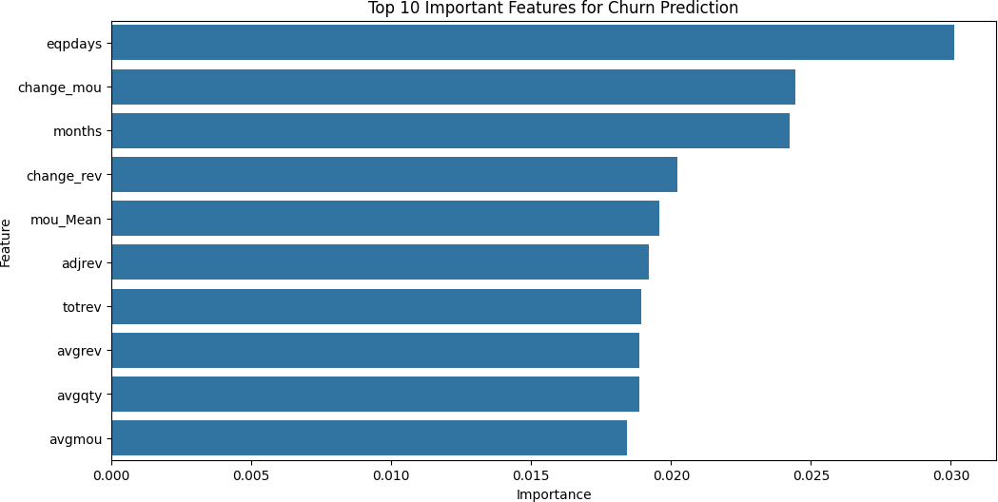

import pandas as pd import numpy as np import seaborn as sns
import matplotlib.pyplot as plt
from sklearn.model_selection import train_test_split from sklearn.linear_model import LinearRegression
from sklearn.metrics import mean_squared_error, r2_score from sklearn.impute import SimpleImputer
# Step 1: Load the dataset
df = pd.read_csv('D:/Telecom_customer_churn.csv')
# Step 2: Basic data preprocessing # Drop irrelevant columns
df = df.drop(columns=['Customer_ID'], errors='ignore') # Ignore if Customer_ID is not present
# Step 3: Check for missing values
print("Missing Values Before Imputation:\n", df.isnull().sum())
# Step 4: Check data types and basic statistics print("Data Overview:\n", df.info()) print("\nBasic Statistics:\n", df.describe())
# Step 5: Prepare the features and target variable # Check if 'churn' is numeric
if df['churn'].dtype != 'int64' and df['churn'].dtype != 'float64': df['churn'] = pd.to_numeric(df['churn'], errors='coerce')
X = df.drop(columns=['churn']) # Features
y = df['churn'] # Target variable
# One-hot encoding for categorical features if needed
X = pd.get_dummies(X, drop_first=True)
# Step 6: Impute missing values in X
imputer = SimpleImputer(strategy='mean') # You can change to 'median' or 'most_frequent' if needed
X_imputed = imputer.fit_transform(X)
# Check for remaining missing values after imputation print("Missing values after imputation:\n", pd.DataFrame(X_imputed).isnull().sum())
# Step 7: Split the data into training and testing sets
X_train, X_test, y_train, y_test = train_test_split(X_imputed, y, test_size=0.3, random_state=42)
# Verify the shapes of the training data
print(f'Shape of X_train: {X_train.shape}, Shape of y_train:
{y_train.shape}')
# Step 8: Create a Linear Regression model
model = LinearRegression()
# Step 9: Train the model
try:
model.fit(X_train, y_train) except ValueError as e:
print(f"Error during fitting: {e}")
# Step 10: Make predictions
y_pred = model.predict(X_test)
# Step 11: Evaluate the model
mse = mean_squared_error(y_test, y_pred) r2 = r2_score(y_test, y_pred)
print("Mean Squared Error:", mse) print("R-squared:", r2)
# Optional: Plot the predicted vs actual values plt.figure(figsize=(10, 6)) plt.scatter(y_test, y_pred)
plt.xlabel('Actual Values') plt.ylabel('Predicted Values') plt.title('Actual vs Predicted Values')
plt.plot([y.min(), y.max()], [y.min(), y.max()], 'k--', lw=2) plt.show()
Missing Values Before Imputation:
mou_Mean totmrc_Mean da_Mean ovrmou_Mean
357
357
357
357
rev_Mean 357

...
kid6_10 | 1732
kid11_15 | 1732
kid16_17 | 1732
creditcd | 1732
eqpdays | 1
Length: 99, dtype: int64
<class 'pandas.core.frame.DataFrame'> RangeIndex: 100000 entries, 0 to 99999 Data columns (total 99 columns):
# Column Non-Null Count Dtype

- rev_Mean 99643 non-null float64
- mou_Mean 99643 non-null float64
- totmrc_Mean 99643 non-null float64
- da_Mean 99643 non-null float64
- ovrmou_Mean 99643 non-null float64
- ovrrev_Mean 99643 non-null float64
- vceovr_Mean 99643 non-null float64
- datovr_Mean 99643 non-null float64
- roam_Mean 99643 non-null float64
- change_mou 99109 non-null float64
- change_rev 99109 non-null float64
- drop_vce_Mean 100000 non-null float64
- drop_dat_Mean 100000 non-null float64
- blck_vce_Mean 100000 non-null float64
- blck_dat_Mean 100000 non-null float64
- unan_vce_Mean 100000 non-null float64
- unan_dat_Mean 100000 non-null float64
- plcd_vce_Mean 100000 non-null float64
- plcd_dat_Mean 100000 non-null float64
- recv_vce_Mean 100000 non-null float64
- recv_sms_Mean 100000 non-null float64
- comp_vce_Mean 100000 non-null float64
- comp_dat_Mean 100000 non-null float64
- custcare_Mean 100000 non-null float64
- ccrndmou_Mean 100000 non-null float64
- cc_mou_Mean 100000 non-null float64
- inonemin_Mean 100000 non-null float64
- threeway_Mean 100000 non-null float64
- mou_cvce_Mean 100000 non-null float64
- mou_cdat_Mean 100000 non-null float64
- mou_rvce_Mean 100000 non-null float64
- owylis_vce_Mean 100000 non-null float64
- mouowylisv_Mean 100000 non-null float64
- iwylis_vce_Mean 100000 non-null float64
- mouiwylisv_Mean 100000 non-null float64
- peak_vce_Mean 100000 non-null float64
- peak_dat_Mean 100000 non-null float64
- mou_peav_Mean 100000 non-null float64
- mou_pead_Mean 100000 non-null float64
- opk_vce_Mean 100000 non-null float64
- opk_dat_Mean 100000 non-null float64
- mou_opkv_Mean 100000 non-null float64
- mou_opkd_Mean 100000 non-null float64
- drop_blk_Mean 100000 non-null float64
- attempt_Mean 100000 non-null float64
- complete_Mean 100000 non-null float64
- callfwdv_Mean 100000 non-null float64
- callwait_Mean 100000 non-null float64
- churn 100000 non-null int64
- months 100000 non-null int64
- uniqsubs 100000 non-null int64
- actvsubs 100000 non-null int64
- new_cell 100000 non-null object
- crclscod 100000 non-null object
- asl_flag 100000 non-null object
- totcalls 100000 non-null int64
- totmou 100000 non-null float64
- totrev 100000 non-null float64
- adjrev 100000 non-null float64
- adjmou 100000 non-null float64
- adjqty 100000 non-null int64
- avgrev 100000 non-null float64
- avgmou 100000 non-null float64
- avgqty 100000 non-null float64
- avg3mou 100000 non-null int64
- avg3qty 100000 non-null int64
- avg3rev 100000 non-null int64
- avg6mou 97161 non-null float64
- avg6qty 97161 non-null float64
- avg6rev 97161 non-null float64
- prizm_social_one 92612 non-null object
- area 99960 non-null object
- dualband 99999 non-null object
- refurb_new 99999 non-null object
- hnd_price 99153 non-null float64
- phones 99999 non-null float64
- models 99999 non-null float64
- hnd_webcap 89811 non-null object
- truck 98268 non-null float64
- rv 98268 non-null float64
- ownrent 66294 non-null object
- lor 69810 non-null float64
- dwlltype 68091 non-null object
- marital 98268 non-null object
ethnic
kid0_2
kid3_5
kid6_10
kid11_15
kid16_17
creditcd
90 forgntvl
HHstatin
dwllsize
income
numbcars
85 infobase
84 adults
98268 non-nullobject
98268 non-nullobject
98268 non-nullobject
98268 non-nullobject
98268 non-nullobject
98268 non-nullobject
98268 non-nullobject
98268 non-nullfloat64
62077 non-nullobject
61692 non-nullobject
74564 non-nullfloat64
50634 non-nullfloat64
77921 non-nullobject
76981 non-nullfloat64
98 eqpdays 99999 non-null float64 dtypes: float64(69), int64(9), object(21) memory usage: 75.5+ MB
Data Overview:
None
Basic Statistics:
rev_Mean mou_Mean totmrc_Mean da_Mean ovrmou_Mean \
count 99643.000000 99643.000000 99643.000000 99643.000000
99643.000000
mean 58.719985 513.559937 46.179136 0.888828
41.072247
std 46.291677 525.168140 23.623489 2.177619
97.296150
min -6.167500 0.000000 -26.915000 0.000000
0.000000
25% 33.260000 150.750000 30.000000 0.000000
0.000000
50% 48.195000 355.500000 44.990000 0.247500
2.750000
75% 70.750000 703.000000 59.990000 0.990000
42.000000
max 3843.262500 12206.750000 409.990000 159.390000
4320.750000
ovrrev_Mean vceovr_Mean datovr_Mean roam_Mean change_mou \
count 99643.000000 99643.000000 99643.000000 99643.000000
99109.000000
mean 13.559560 13.295062 0.261318 1.286405 -
13.933818
std 30.500885 30.056089 3.126531 14.711374
276.087509

min 0.000000 0.000000 0.000000 0.000000 -
3875.000000
25% 0.000000 0.000000 0.000000 0.000000 -
87.000000
50% 1.000000 0.682500 0.000000 0.000000 -
6.250000
75% 14.437500 14.025000 0.000000 0.235000
63.000000
max 1102.400000 896.087500 423.540000 3685.200000
31219.250000

... | phones | models | truck | rv | \
count ... | 99999.000000 | 99999.000000 | 98268.000000 | 98268.000000
mean ... | 1.787118 | 1.545825 | 0.188820 | 0.082580
std ... | 1.313977 | 0.898395 | 0.391368 | 0.275248
min ... | 1.000000 | 1.000000 | 0.000000 | 0.000000
25% ... | 1.000000 | 1.000000 | 0.000000 | 0.000000
50% ... | 1.000000 | 1.000000 | 0.000000 | 0.000000
75% ... | 2.000000 | 2.000000 | 0.000000 | 0.000000
max ... | 28.000000 | 16.000000 | 1.000000 | 1.000000
lor adults income numbcars
forgntvl \
count 69810.000000 76981.000000 74564.000000 50634.000000
98268.000000
mean 6.177238 2.530326 5.783112 1.567563
0.057974
std 4.735267 1.452819 2.182132 0.625456
0.233696

min 0.000000 1.000000 1.000000 1.000000
0.000000
25% 2.000000 1.000000 4.000000 1.000000
0.000000
50% 5.000000 2.000000 6.000000 1.000000
0.000000
75% 9.000000 3.000000 7.000000 2.000000
0.000000
max 15.000000 6.000000 9.000000 3.000000
1.000000

 | eqpdays
count | 99999.000000
mean | 391.932309
std | 256.482193
min | -5.000000
25% | 212.000000
50% | 342.000000
75% | 530.000000
max | 1823.000000

[8 rows x 78 columns]
Missing values after imputation:
00
Length: 209, dtype: int64
Shape of X_train: (70000, 209), Shape of y_train: (70000,) Mean Squared Error: 0.2386877139144143
R-squared: 0.0452450664779378

1 | 0
2 | 0
3 | 0
4 | 0
 | ..
204 | 0
205 | 0
206 | 0
207 | 0
208 | 0

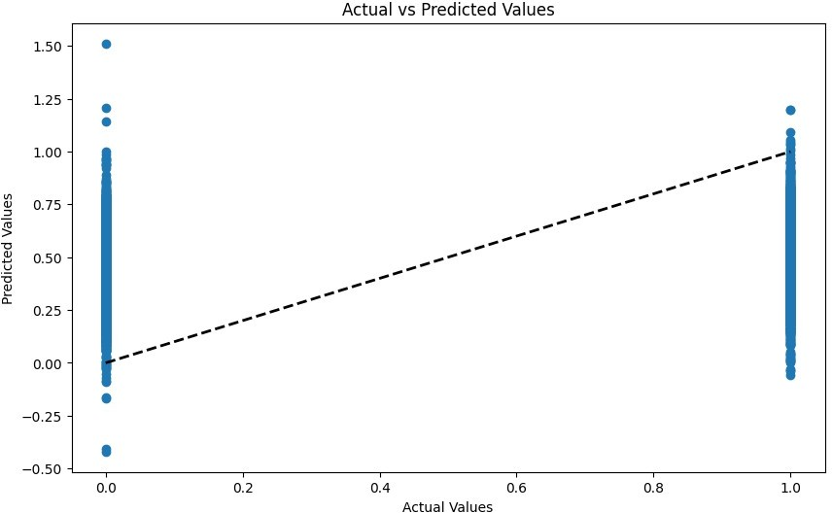
import pandas as pd import numpy as np import seaborn as sns
import matplotlib.pyplot as plt
from sklearn.model_selection import train_test_split from sklearn.linear_model import LinearRegression
from sklearn.metrics import mean_squared_error, r2_score,

accuracy_score, precision_score, recall_score, f1_score, classification_report
from sklearn.impute import SimpleImputer
# Step 1: Load the dataset
df = pd.read_csv('D:/Telecom_customer_churn.csv')
# Step 2: Basic data preprocessing
df = df.drop(columns=['Customer_ID'], errors='ignore') # Ignore if Customer_ID is not present
# Step 3: Check for missing values
print("Missing Values Before Imputation:\n", df.isnull().sum())
# Step 4: Check data types and basic statistics print("Data Overview:\n", df.info()) print("\nBasic Statistics:\n", df.describe())
# Step 5: Prepare the features and target variable
if df['churn'].dtype != 'int64' and df['churn'].dtype != 'float64': df['churn'] = pd.to_numeric(df['churn'], errors='coerce')
X = df.drop(columns=['churn']) # Features
y = df['churn'] # Target variable
# One-hot encoding for categorical features if needed
X = pd.get_dummies(X, drop_first=True)
# Step 6: Impute missing values in X imputer = SimpleImputer(strategy='mean') X_imputed = imputer.fit_transform(X)
# Step 7: Split the data into training and testing sets
X_train, X_test, y_train, y_test = train_test_split(X_imputed, y, test_size=0.3, random_state=42)
# Step 8: Create a Linear Regression model
model = LinearRegression()
# Step 9: Train the model
try:
model.fit(X_train, y_train) except ValueError as e:
print(f"Error during fitting: {e}")
# Step 10: Make predictions
y_pred = model.predict(X_test)
# Step 11: Convert predictions to binary (0 or 1)
y_pred_binary = (y_pred > 0.5).astype(int)
# Step 12: Calculate and print evaluation metrics accuracy = accuracy_score(y_test, y_pred_binary) precision = precision_score(y_test, y_pred_binary) recall = recall_score(y_test, y_pred_binary)
mou_Mean totmrc_Mean da_Mean ovrmou_Mean
357
357
357
357
f1 = f1_score(y_test, y_pred_binary)
print("Model Evaluation Metrics:") print("Accuracy:", accuracy) print("Precision:", precision) print("Recall:", recall) print("F1 Score:", f1)
# Optional: Print classification report
print("\nClassification Report:\n", classification_report(y_test, y_pred_binary))
# Optional: Plot the predicted vs actual values plt.figure(figsize=(10, 6)) plt.scatter(y_test, y_pred_binary) plt.xlabel('Actual Values') plt.ylabel('Predicted Values')
plt.title('Actual vs Predicted Values (Binary)') plt.plot([0, 1], [0, 1], 'k--', lw=2) plt.show()
Missing Values Before Imputation:
rev_Mean 357

...
kid6_10 | 1732
kid11_15 | 1732
kid16_17 | 1732
creditcd | 1732
eqpdays | 1
Length: 99, dtype: int64
<class 'pandas.core.frame.DataFrame'> RangeIndex: 100000 entries, 0 to 99999 Data columns (total 99 columns):
# Column Non-Null Count Dtype

0 rev_Mean 99643 non-null float64
1 |  | mou_Mean | 99643 non-null |  | float64
2 |  | totmrc_Mean | 99643 non-null |  | float64
3 |  | da_Mean | 99643 non-null |  | float64
4 |  | ovrmou_Mean | 99643 non-null |  | float64
5 |  | ovrrev_Mean | 99643 non-null |  | float64
6 |  | vceovr_Mean | 99643 non-null |  | float64

- datovr_Mean 99643 non-null float64
- roam_Mean 99643 non-null float64
- change_mou 99109 non-null float64
- change_rev 99109 non-null float64
- drop_vce_Mean 100000 non-null float64
- drop_dat_Mean 100000 non-null float64
- blck_vce_Mean 100000 non-null float64
- blck_dat_Mean 100000 non-null float64
- unan_vce_Mean 100000 non-null float64
- unan_dat_Mean 100000 non-null float64
- plcd_vce_Mean 100000 non-null float64
- plcd_dat_Mean 100000 non-null float64
- recv_vce_Mean 100000 non-null float64
- recv_sms_Mean 100000 non-null float64
- comp_vce_Mean 100000 non-null float64
- comp_dat_Mean 100000 non-null float64
- custcare_Mean 100000 non-null float64
- ccrndmou_Mean 100000 non-null float64
- cc_mou_Mean 100000 non-null float64
- inonemin_Mean 100000 non-null float64
- threeway_Mean 100000 non-null float64
- mou_cvce_Mean 100000 non-null float64
- mou_cdat_Mean 100000 non-null float64
- mou_rvce_Mean 100000 non-null float64
- owylis_vce_Mean 100000 non-null float64
- mouowylisv_Mean 100000 non-null float64
- iwylis_vce_Mean 100000 non-null float64
- mouiwylisv_Mean 100000 non-null float64
- peak_vce_Mean 100000 non-null float64
- peak_dat_Mean 100000 non-null float64
- mou_peav_Mean 100000 non-null float64
- mou_pead_Mean 100000 non-null float64
- opk_vce_Mean 100000 non-null float64
- opk_dat_Mean 100000 non-null float64
- mou_opkv_Mean 100000 non-null float64
- mou_opkd_Mean 100000 non-null float64
- drop_blk_Mean 100000 non-null float64
- attempt_Mean 100000 non-null float64
- complete_Mean 100000 non-null float64
- callfwdv_Mean 100000 non-null float64
- callwait_Mean 100000 non-null float64
- churn 100000 non-null int64
- months 100000 non-null int64
- uniqsubs 100000 non-null int64
- actvsubs 100000 non-null int64
- new_cell 100000 non-null object
- crclscod 100000 non-null object
- asl_flag 100000 non-null object
- totcalls 100000 non-null int64
- totmou 100000 non-null float64
- totrev 100000 non-null float64
- adjrev 100000 non-null float64
- adjmou 100000 non-null float64
- adjqty 100000 non-null int64
- avgrev 100000 non-null float64
- avgmou 100000 non-null float64
- avgqty 100000 non-null float64
- avg3mou 100000 non-null int64
- avg3qty 100000 non-null int64
- avg3rev 100000 non-null int64
- avg6mou 97161 non-null float64
- avg6qty 97161 non-null float64
- avg6rev 97161 non-null float64
- prizm_social_one 92612 non-null object
- area 99960 non-null object
- dualband 99999 non-null object
- refurb_new 99999 non-null object
- hnd_price 99153 non-null float64
- phones 99999 non-null float64
- models 99999 non-null float64
- hnd_webcap 89811 non-null object
- truck 98268 non-null float64
- rv 98268 non-null float64
- ownrent 66294 non-null object
- lor 69810 non-null float64
- dwlltype 68091 non-null object
- marital 98268 non-null object
- adults 76981 non-null float64
- infobase 77921 non-null object
- income 74564 non-null float64
- numbcars 50634 non-null float64
- HHstatin 62077 non-null object
- dwllsize 61692 non-null object
- forgntvl 98268 non-null float64
- ethnic 98268 non-null object
- kid0_2 98268 non-null object
- kid3_5 98268 non-null object
- kid6_10 98268 non-null object
- kid11_15 98268 non-null object
- kid16_17 98268 non-null object
- creditcd 98268 non-null object
- eqpdays 99999 non-null float64 dtypes: float64(69), int64(9), object(21) memory usage: 75.5+ MB
Data Overview:
None
Basic Statistics:

rev_Mean mou_Mean totmrc_Mean da_Mean
ovrmou_Mean \
count 99643.000000 99643.000000 99643.000000 99643.000000
99643.000000
mean 58.719985 513.559937 46.179136 0.888828
41.072247
std 46.291677 525.168140 23.623489 2.177619
97.296150
min -6.167500 0.000000 -26.915000 0.000000
0.000000
25% 33.260000 150.750000 30.000000 0.000000
0.000000
50% 48.195000 355.500000 44.990000 0.247500
2.750000
75% 70.750000 703.000000 59.990000 0.990000
42.000000
max 3843.262500 12206.750000 409.990000 159.390000
4320.750000
ovrrev_Mean vceovr_Mean datovr_Mean roam_Mean change_mou \
count 99643.000000 99643.000000 99643.000000 99643.000000
99109.000000
mean 13.559560 13.295062 0.261318 1.286405 -
13.933818
std 30.500885 30.056089 3.126531 14.711374
276.087509
min 0.000000 0.000000 0.000000 0.000000 -
3875.000000
25% 0.000000 0.000000 0.000000 0.000000 -
87.000000
50% 1.000000 0.682500 0.000000 0.000000 -
6.250000
75% 14.437500 14.025000 0.000000 0.235000
63.000000
max 1102.400000 896.087500 423.540000 3685.200000
31219.250000

... | phones | models | truck | rv | \
count ... | 99999.000000 | 99999.000000 | 98268.000000 | 98268.000000
mean ... | 1.787118 | 1.545825 | 0.188820 | 0.082580
std ... | 1.313977 | 0.898395 | 0.391368 | 0.275248
min ... | 1.000000 | 1.000000 | 0.000000 | 0.000000
25% ... | 1.000000 | 1.000000 | 0.000000 | 0.000000
50% ... | 1.000000 | 1.000000 | 0.000000 | 0.000000
75% ... | 2.000000 | 2.000000 | 0.000000 | 0.000000
max ... | 28.000000 | 16.000000 | 1.000000 | 1.000000
lor adults income numbcars
forgntvl \

count 69810.000000 76981.000000 74564.000000 50634.000000
98268.000000
mean 6.177238 2.530326 5.783112 1.567563
0.057974
std 4.735267 1.452819 2.182132 0.625456
0.233696
min 0.000000 1.000000 1.000000 1.000000
0.000000
25% 2.000000 1.000000 4.000000 1.000000
0.000000
50% 5.000000 2.000000 6.000000 1.000000
0.000000

75% 9.000000 3.000000 7.000000 2.000000
0.000000
max 15.000000 6.000000 9.000000 3.000000
1.000000

 | eqpdays
count | 99999.000000
mean | 391.932309
std | 256.482193
min | -5.000000
25% | 212.000000
50% | 342.000000
75% | 530.000000
max | 1823.000000

[8 rows x 78 columns] Model Evaluation Metrics:
Accuracy: 0.5898666666666667
Precision: 0.5895316804407713
Recall: 0.5861446990446924
F1 Score: 0.5878333110009379
Classification Report:
precision recall f1-score support

0 | 0.59 | 0.59 | 0.59 | 15031
1 | 0.59 | 0.59 | 0.59 | 14969
accuracy |  |  | 0.59 | 30000
macro avg | 0.59 | 0.59 | 0.59 | 30000
weighted avg | 0.59 | 0.59 | 0.59 | 30000

